Accessible via: https://www.caseyresearch.com/cs/project-fedcoin-cs
[Summary: A new currency (“FEDcoins”, say), based on blockchain Technology, will be introduced in the USA. Initially equal to the existing fiat I-owe-you-nothing Federal Reserve Notes, it will allow the FED to later distinguish
- property-based, meaningfully backed (with monetary metals initially, one speculates), money from
- the current “Federal Reserve Note” money (supporting not only daily purchase but described by Jeffrey Snyder as Financialism) whose backing is debt offered by financial speculators.]

“Project: FEDcoin”
- Currency expert who predicted
- gold boom of the 70s,
- Savings & Loan collapse of the 80s,
- the Dot Com and housing crashes, as well as
- President Trump's victory
makes startling prediction about the fate of the U.S. dollar…
“One of the great prophets of our time.”
Robert J. Ringer,
#1 NY Times bestselling financial author
Special Investigation
Anchor: Bob Irish
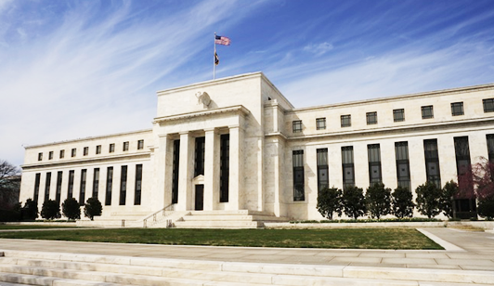
What you’re looking at here is one of the most important buildings in Washington, D.C.
But it’s not the White House, the Supreme Court or the U.S. Capitol.
No. This is the headquarters of America’s Federal Reserve Bank.
How much interest you pay on a loan…
How much money you earn on your savings…
It’s all controlled by the men and women inside this building.
And I just got wind that—behind these white walls—the people in charge of “the Fed” are scrambling to keep America’s money system alive.
In fact, according to my source, Fed members just wrapped up a special “behind-closed-doors” meeting to discuss one of the most dramatic changes to the U.S. dollar in the last 100 years.
A change that not only affects how we spend, save, and earn…
But that will also transform the very nature of “money” itself.
To uncover the story, I flew down to Aspen, Colorado to meet with NY Times Best-Selling author, currency expert and multi-millionaire speculator Doug Casey.
Casey is one of the most connected men in the financial world:
He was Bill Clinton’s classmate at Georgetown… He’s debated presidential candidates… He’s met with (and spoke at the same national conference as) former Fed Chairman Alan Greenspan… And he’s also been invited by the leaders of twelve different countries to discuss monetary reform. Some even credit Casey with introducing the concept of “economic citizenship,” where individuals can become citizens of a country simply by making an investment.
In the interview that follows, you’ll hear Casey’s strong warning to Americans regarding the consequences of a new potential money plan by the Fed that could start in the next 6 months.
You’ll also hear the four steps he’s personally taking today to prepare himself and protect his savings.

Doug [Casey], thanks for agreeing to meet me here on such short notice.
My pleasure Bob.
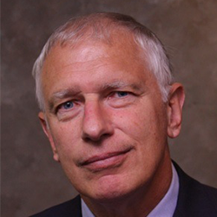
Doug, as you know, I'm here because you believe something shocking and disturbing is going on in Washington right now. Something that will catch the average American completely off guard and will be dangerous to their financial well-being.
That's right Bob. In short, I think that we are in line for one of the most drastic and draconian changes to the US money system in history. It could be on par with
- the creation of the Fed in 1913 or
- Roosevelt confiscating American citizen's gold in 1933 or
- Johnson taking silver out of the US coinage in 1965 or
- Nixon devaluing the dollar and cutting it loose from gold in 1971.
Doug, I've tracked your career closely since you wrote your best-selling book Crisis Investing back in 1979. I know you're not one of those gurus to make huge predictions just to get in the spotlight. When you make a prediction, more often than not, history has proven you right.
For example, in your book, you warned corporations would go “belly up on a massive scale, but that the government would bail out those which are most inefficient.” Sure enough, the S&L crisis ensued with over 1,000 bankruptcies followed by the Bush bailout in 1989.
Well, a good economist, among other things, anticipates not only the immediate and direct consequences of government actions, but the indirect and delayed consequences as well. Unfortunately, most of the economic pundits you read about are actually just political apologists.
Doug, you've issued at least one major prediction in each of the last four decades. Let's take a quick look:
In '84 you issued this public warning; you said, and I quote, that, "Suicidal terrorists will run amok striking in capitals of Western nations including Washington and Wall Street." That was nine years before the first attack on the World Trade Center and, of course, we all remember the horror of 9/11.
Then in 1989, nine months before the fall of the Berlin wall, you wrote, "The Soviets are likely to see their country break up into its many constituent parts over the next few decades."
November, 1999, four months before the NASDAQ lost over 60%, you said, "Almost every one of the Internet stocks is a burning match." You said we would see, quote "…a 95% plus meltdown among the survivors with many disappearing totally." Amazon, one of survivors you specifically mentioned was overpriced at the time, fell 93% over the next 18 months; uncanny…
But it's not all gloom and doom.
The same year you made a strong call for gold. You wrote, "I think the price of gold is at the bottom and over the next few years it's not just going through the roof, but to the moon." Sure enough, gold was trading for $259 at the time, but it eventually rose to $1,900, offering those who followed your advice the chance to turn $10,000 into more than $72,000.
Lastly, in 2005, two years before the housing crash, you issued this public statement; you said, "What's going on now in the residential real estate market is much like the tech bubble, but potentially much more serious than what went on in stocks a few years ago. The bubble is floating on a sea of debt. When it bursts, millions of houses will hit the market in distressed sales." This was another warning that could've helped millions of Americans steer clear of disaster.
Now Doug, I'm not going to list all the predictions you've ever made, but these showcase why financial author Robert Ringer has called you one of the “great prophets of our time” and why Simon & Schuster has stated you've “never been wrong on one of your major predictions.” Phil Donahue even once devoted a full hour long show to your work.
Today we are going to discuss the subject of your research firm's latest book, Surviving Fedcoin, which outlines what may be your most shocking prediction yet. If you're right about this, like you've been in the past, the consequences could be devastating for most Americans. The savings of millions could be drastically reduced and it could spell the end of one of our most cherished liberties.
Well, Bob, I don't have a crystal ball; I'm not a fortune-teller, but I believe that in the real world, cause has effect and actions have consequences. So the key is to position yourself. Sometimes it takes a few years for the inevitable to become imminent.

What’s Going On?
Okay Doug, let's just dive right into it… What is going on?
I believe that we entered the greater depression in 2007.
We entered – compare it to a gigantic financial hurricane and what we experienced in 2007, 2008, 2009, 2010… was the early, leading edge of this gigantic financial hurricane. Now, for the last six years, we've been in the eye of the storm. I believe at this point we are entering the trailing edge of the hurricane and this is going to be much different, much worse, and much longer lasting than the turbulence we experienced back in '08 and '09.
The eye of the storm was caused by governments around the world. Not just the US government, but the Europeans, the Chinese, the Japanese; all of them; and minor governments as well, creating trillions and trillions of currency units that they cast upon this financial hurricane like oil on water.
It made things seem better than they were. It made people feel that they were richer than they were for this last six years in the eye of the storm, but it's going to be, I think, the biggest upset in economic history. Much bigger and much worse than what we experienced in the last Great Depression from 1929 to 1945…
Wow… Worse than the '29 depression? How bad can this get?
The bond market is in a super bubble at this point; not just a bubble. The real estate market… is in another bubble.
The stock market…It's a speculation at this point… People forget that in between 1929 and 1932, the stock market collapsed 93%.
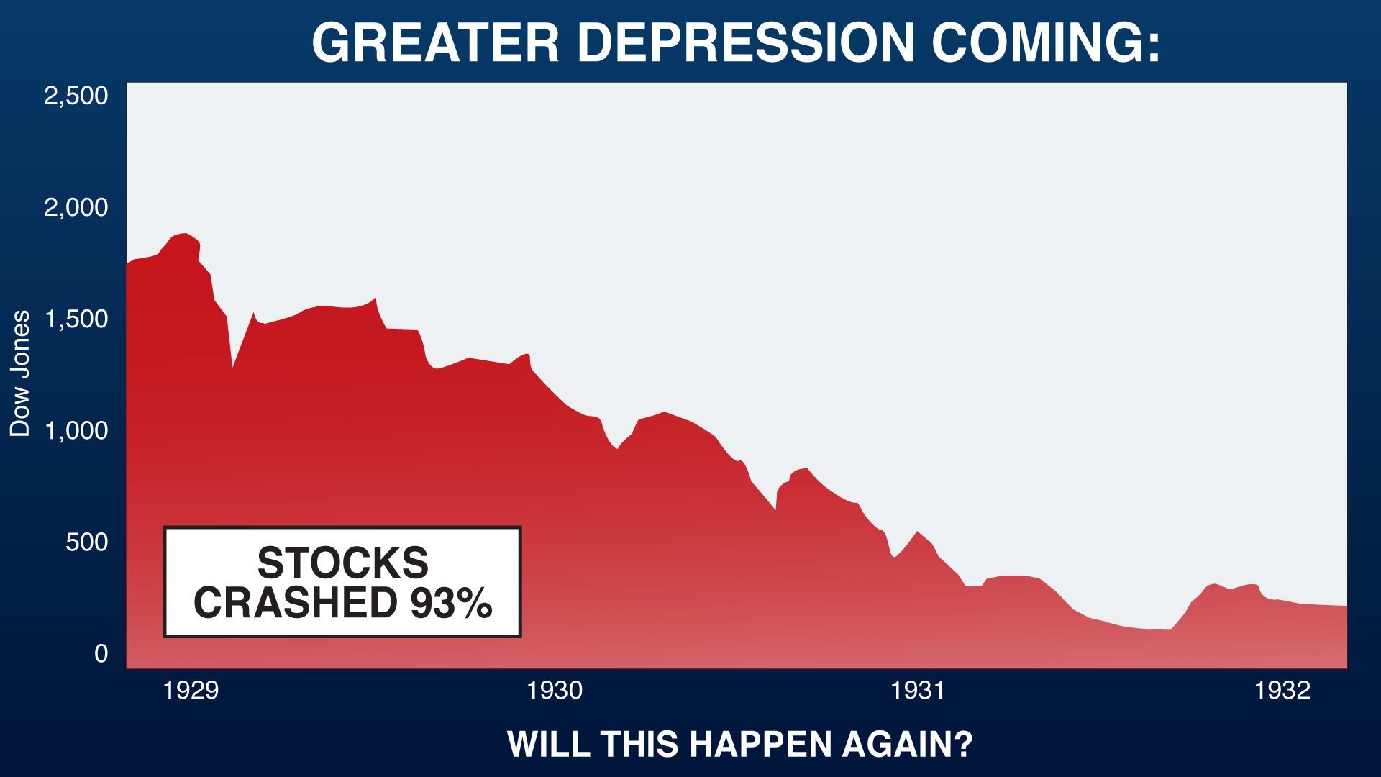
When the banking crisis hit Cyprus three years ago, this is rather unbelievable but it's true, the stock market in Cyprus collapsed almost 99%.
My goodness.
Anything is possible in circumstances like this. Look, in 2008, in September, it's acknowledged by members of the Federal Reserve that we came within hours of the total collapse of the financial system. AIG, Merrill Lynch, Goldman Sachs, commercial banks; they came in within hours of total collapse.
Why?
Well, one of the reasons why is, as Warren Buffett has pointed out, there are about, at this point, much more than there were back in 2007 and 2008, there are about a quadrillion dollars' worth of derivatives. These are very complex contracts that one financial institution owes another who sells it on to the next and sells it on to the next one. It's a gigantic daisy chain and if just one of these institutions can't make a payment, the next guy can't make a payment and the next guy.
When you go to redeem or cash your paycheck at Citibank or whoever, what are they going to give you? They're bankrupt because of people not being able to pay them.
This is how it all comes down and the banks actually close. This is what the fractional reserve system is about.
So, Doug, in what ways is the system even riskier than it was in, say 2008?
Frankly, every way. Not only is the stock market much higher, the bond market much more in a super bubble, real estate, financial institutions are much more liquid…
In 2010, the Federal Reserve published a paper which said that they couldn't possibly have come up with the assets, the currency to – to bail the thing out… and this time, it's much more serious than it was back then. There's much more debt in the world.
So what are they going to do?... With the negative interest rate environment we have today, people don't want to put their money in the banking system. They're being punished for putting money in the banking system. And this makes a bank run even more likely than it was in 2008.
I'm not talking about five years or ten years from now. I'm talking about going back into the trailing edge of the storm in a matter of months
The U.S. at this point is a ticking time bomb from a financial, from an economic, from a sociological, from a political point of view. It's a very dangerous situation…

Money System “Extremely Unstable”
Let's talk about this change in the US money system. Doug, what do you believe is going to happen?
Well, the monetary system is extremely unstable and money is the lifeblood of an economy …you poison the monetary system, it's like getting blood poisoning. It will kill you eventually. We are seeing this now.
The dollar has lost about 96-97% of its value since the creation of the Federal Reserve in 1913.
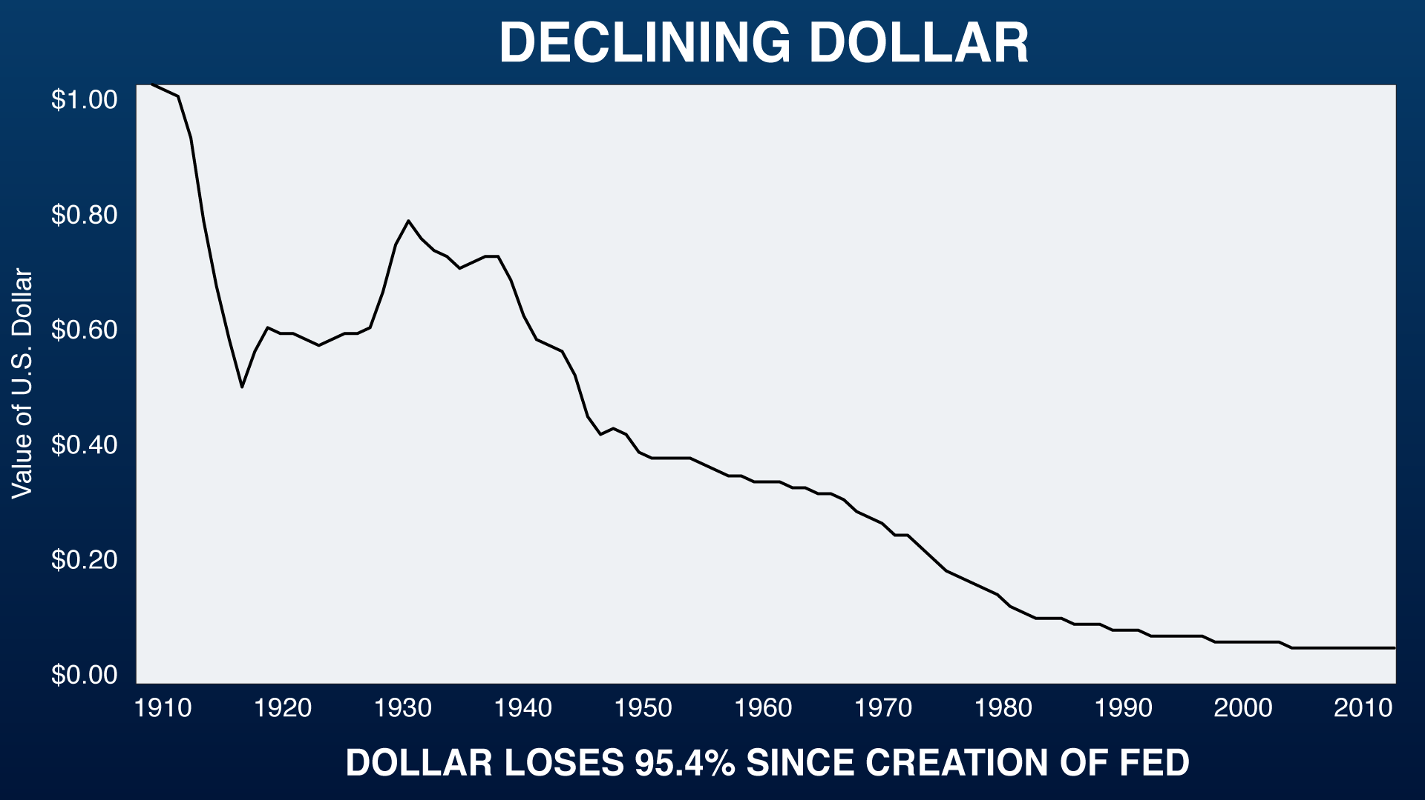
That trend is not only going to continue, but at this point, it's going to accelerate rapidly. One of the things that's helped a lot recently is the fact that it's the world's reserve currency.
There are about $10 trillion USD outside of the US. This is a big problem because the major export of the United States for the last 30 years has been dollars. The nice Japanese send us Sonys and Toyotas and the nice Germans send us Mercedes and we basically just print up dollars and send it to them. That's how $10 trillion got outside the US.
It used to be that – just after World War II, all the skyscrapers in the world, 80% of aircraft production in the world, 80% of the automobile production in the world, 75% of the steel production the world, 75% of the stock market value in the world; it was all in America. America was the end all, the be-all. It was the king of the hill. Now, none of these things are true anymore…
The standard of living of the average American peaked in the mid-1950s. Let say in 1959, when the 1959 Cadillac with its fins and twin bullet taillights came out. It's actually – if it peaked then, then it started heading down in earnest in about 1971 with the devaluation of the dollar…
Unfortunately the dollar rests on nothing more than confidence because it's an “I owe you nothing”; I'm a part of a bankrupt government and the US government, make no mistake, is bankrupt. Its liabilities far, far exceed its assets.
So when the confidence blows away, the first people to dump the dollar are going to be foreigners. All those dollars, the $10 trillion abroad, are going to come back into the United States in exchange for what? Share certificates, titles to real estate, to companies, to real goods, to Boeings, to IBM's, and the dollars are going to come in.
I mean, inflation could explode in this country. It's a very, very unstable situation from many points of view.

Leaving the Dollar…
So Doug, a number of countries are already abandoning the dollar.
Yes.
I read about a trade agreement… Twenty-five countries recently struck deals to trade outside the dollar. China and Russia reached a $400 billion energy deal to trade outside the dollar…
So this is a trend that's in place right now and you expect that to –
It's a trend that's accelerating actually because at this point when the Russians trade with the Chinese, which they do, what do you use? They use U.S. dollars, but the U.S. government is an enemy of both. They can see the illogic of trading with each other and having it clear through New York. At the same time, the Iranians trade with the Indians. A lot of big traders around the world that are using the dollar because it's kind of the world's currency, but that's going to end because none of them trust the dollar anymore.
The dollar has got a half-life. It's an I owe you nothing on the part of the US government which the whole world increasingly sees as bankrupt.
Social Security is bankrupt… Forty-seven percent of the people in this country are net recipients of money from the government… Officially, one third of all the US government's assets are student loans; little-known fact. About $1 trillion worth of them.
Wow.
So it's going to reach its intrinsic value in unfortunately, since the dollar is backed by nothing, and we are running massive deficits every year, even during this – these relatively good times since 2010. I'm afraid that the dollar is going to be destroyed.
This is a big problem for Americans that are saving in dollars because if you are a productive citizen you produce more than you consume, you save; what do you save?
You save dollars.
If the government destroys the dollar quickly, not just gradually as has been going on for decades, you are going to be out of luck. So you've got to do something about it. You've got to prepare for this eventuality.
Doug, it sounds like our currency and the monetary system in general is in real trouble.
It's in very big trouble.
Look, during the entire 19th century, which was the greatest sustained period of growth in world history of any country, in the United States the dollar was completely stable.
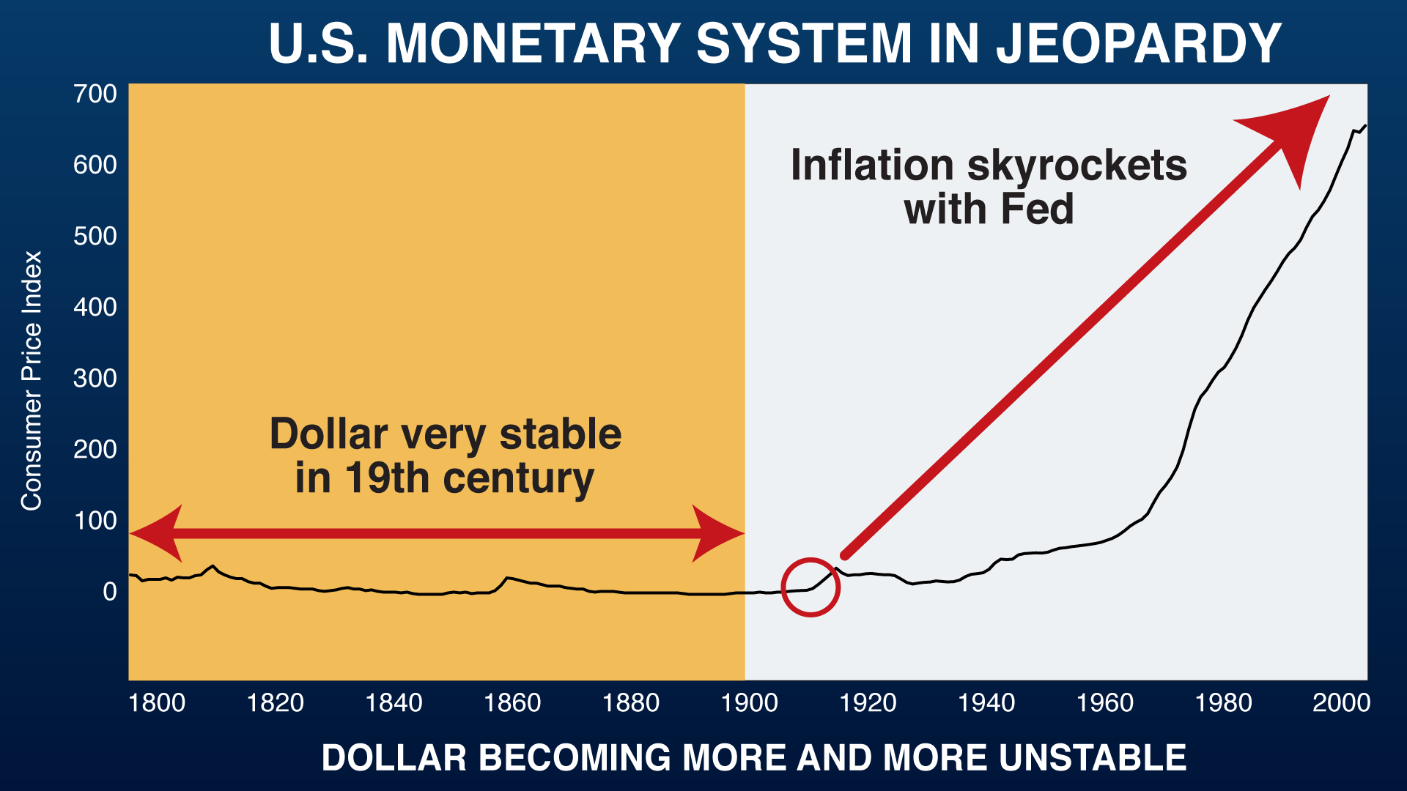
The dollar was defined as 1/20th of an ounce of gold. The price level was completely stable even going down during that time which encouraged people to save which was a good thing.
Then the Federal Reserve was created in 1913. Now it made it possible for all kinds of strange things to happen in the banking system. That resulted, the creation of the Federal Reserve, resulted directly in the credit collapse, deflationary depression of 1929 to 1945.

Doug’s Prediction
So Doug, what do you actually see happening with the dollar?
My thought is this; that understanding that the dollar is unstable as it is, at this point the Fed might try to create an alternative. And an alternative that's more under their control than the dollar and actually out of the traditional banking system. What would happen if the Federal Reserve created a look-alike dollar? Let's call it the Fedcoin. Perhaps based on the same technology that Bitcoin is based on. This is the blockchain technology where every transaction can be tracked from the creation of the Bitcoin itself.
I suspect the next stage on the part of the governments since they've tried quantitative easing; can't do that too much more after creating trillions and trillions of these paper dollars which are going to come out of the financial system and into the retail system exploding prices.
Zero interest rates and negative interest rates; huge distortions. That's going to come to an end.
What are they going to do next when the – as we enter the trailing edge of the hurricane and everybody will say, do something, do something? Well, what can they do? They've used their two major tools so far.
My guess is they're going to come up with a – with a completely digital currency called the Fedcoin which will actually act as a parallel, alternative to the dollar. It will have a lot of advantages from the government's point of view and as much of people seem to like Bitcoin, the public may accept it to start with.
So, Doug, tell me about this Fedcoin. What's it gonna look like?
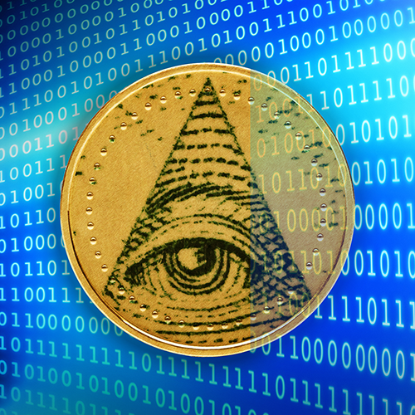
Well, this is a conjecture on my part. It's not going to be physical, to start with. It's not gonna be paper in any way.
It's going to be something that you're going to have on your smartphone, or let's take this to the next level, as outrageous and scary as it may sound, maybe it's just gonna be a chip that you put in your hand where your bank account, your medical records, all these things, be very salable.
People are chipping their dogs and their other pets today. Wear that chip yourself and carry all your information and your digital money right with you. You can't lose your hand; you might lose your smartphone.
So that's the next step. I'm trying to stay one step ahead of what these people are doing, and at this point, we really are between a rock and a hard place. I don't know what their alternative is.
Well, Doug, it's not as far-fetched, I guess, as some people might believe. I think they have something going on in Japan right now for tourists… paying with fingerprints…
You're right, Bob. Actually, reality is outrunning science fiction at this point.
As of next year, tourists to Japan, when they enter the country, have to be fingerprinted and their financial data for their credit cards and so forth correlated so that this is actually happening in Japan so that when you – if you're a tourist in the country, you'll also have to use your thumbprint or fingerprint when you use your credit card. So no, the next step clearly is something along these lines.

Bye, Bye Franklin…
So Doug, are you suggesting that actual, physical cash could be banned here in America?
I'm not sure banned is the right word because there are going to be people that don't have smart phones, that won't want to be chipped, so forth. So there is room for social change; 5s and 10s and 20s; small change to buy a Starbucks coffee, but any serious cash, forget about it…
This is the latest version of the $100 bill that I've got here, right, but do you remember not so long ago it used to be a little round circle? I mean, they keep – they keep changing the $100 bill. I think in the last ten years, we've probably had three or four different $100 bills. Maybe this is getting the public used to the fact that these things can change a lot, and quickly.
Yeah, well, actually, Larry Summers mentioned recently that he thinks that $100 bill you're holding in your hands right now should be abolished.
He has. Larry Summers, a man with a high IQ who says lots of stupid and dangerous things.
But he's in a position to see his notions enforced upon society, and I don't doubt that he will succeed because… you know… up until 1969, $500 bills, $1,000 bills actually floated in the U.S. You didn't see them very often, but they were legal tender, they existed. Now they're completely gone, and I'll warrant that, in five years, two years, perhaps even one year, you won't see these anymore either.
Say goodbye to the Franklin…
Exactly…
The day is gonna come when this isn't worth the paper it's printed on. Currencies – paper currencies, fiat currencies have a half-life. They're like radioactive elements.
As this cashless society sort of evolves from here, do you see a potential run on the banks?
Sure.
I mean, people have to be afraid of not being able to have cash; I mean, for some of the reasons you mentioned.
Exactly, and especially as the $100 bill is taken out of circulation, which is the next thing that's going to happen…
Look, try this; go down to your local neighborhood bank and ask the teller to give you $5,000 in cash. First of all, she's going to fill out a suspicious activities report on you which is rather discouraging against the concept of taking cash out. But I doubt if she will even have $5,000 in cash in the bank. Banks aren't dealing in cash. They are dealing in checks and debits and credits on computer.
The Fed has admitted if there were – if there were to be a run on a bank, they don't have enough cash to meet that.
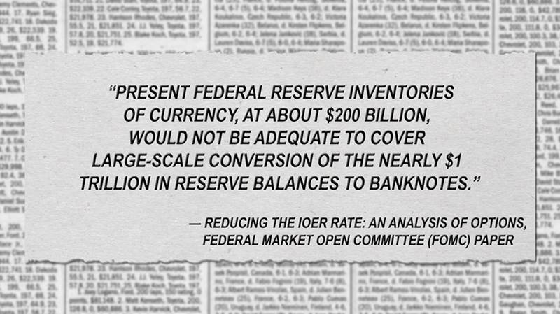
No, of course not because how can they print up hundreds of billions of dollars overnight so that when people go to their bank to cash their checks, they can be rewarded with $50 and $100 bills?
It's not even technically feasible to do that. So somebody takes a check from his employer, puts it in the bank, can't get cash back. What's the bank gonna do? Give him another check that he can't do anything with?
I read somewhere that if all the cash that was needed to meet the obligations, the digital obligations, that are in the bank, if you had to print that amount of cash, it would take 20 years to print enough bills to satisfy demand…
Those are the numbers that I understand because printing up 100s, forget about printing up 5s and 10s and 20s, it takes a long time. I mean, it's a complicated process.
So if there was a run on the banks and people wanted cash, it would be physically impossible to give them enough cash. It would take years. It would take decades for the government to print up enough dollar bills; 20s or 50s or whatever, to give people what they want…
Well, Doug, it sounds like the ordinary American is getting trapped.
Oh, of course he's being trapped.
I mean, historically he could no longer use gold after 1933. Silver was out of the coinage in 1966. The dollar was completely unbacked by anything since 1971. Recent years with things like the PFIC and FATCA and so forth, it's now almost impossible as a practical matter for an American to open up a bank or brokerage account outside the U.S.
Look, the thing to remember is that cash is on its way out. Not just in the United States, but all over the world.
In Sweden, it's almost a cashless economy. In France, in Italy, in Spain, it's illegal to transact for more than €1,000 or €2,000 of cash … The euro, the €500 note is being phased out… The reason for this is that if the banks are untrustworthy and interest rates are zero or negative, why leave your money in a bank? It costs you less to put it under your mattress actually.
But they don't want people to have cash.
Why? Because they say a cash economy facilitates tax evasion. It facilitates underground transactions. It facilitates drug transactions. It facilitates terrorism where $100 bills are passed around in suitcases and so forth. So they would like to kill all currency.
Now what are you going to do?
You can't leave money in the bank because you're getting zero or negative interest rates. The bank itself where you are leaving your money is unstable, illiquid; probably even insolvent. You can't have cash because the most that they're going to have in the future are 10s and 20s. So what are you going to do?
I mean, you're really trapped at this point.
Doug, we keep hearing more and more about these negative interest rates. Can you explain a little bit more what that means?
Well, it's an extremely bad idea because it discourages people from saving, and saving is what builds capital. So it's very destructive for the economy, actually for civilization itself over the long run.
But the idea is that they're trying to encourage people to consume more. It's actually bizarre… They're trying to encourage people to save less and consume more, even though the way you become wealthy, whether you're an individual or company or country, is by producing more and consuming less.
So it's a – it's a different – it's a desperate effort to keep the current order of things from collapsing. But the more of this type of thing they do, the more certain the collapse becomes and the more devastating it'll be when it does unfold, and I think we're right on the edge of it now.
Negative interest rates—Are we gonna go there in this country?
Well, look, since U.S. has some of the – even though our interest rates are close to zero, they're higher than anybody else's. So the dollar's getting stronger and stronger. Well, it's like a dying horse being given a shot of penicillin to make it stronger temporarily. But the stronger the dollar gets, the weaker the U.S. export situation becomes. It's – it's very problematical.
So Doug, what's the advantage of the Fedcoin, if you will, from the Fed's point of view?
Oh, it's a huge advantage for them because in the 2008 crisis, they like to blame a lot of the problems on a lack of transparency, but with blockchain and the Fedcoin technology, they can see everything, everywhere.
So it's complete transparency where they can see everything, everywhere that everybody is doing…
It's a parallel system relative to the one we have right now where if anything goes wrong with the U.S. banking system, the U.S. insurance system, you've got the Fedcoin as a backup…. Fedcoin gives them an extremely powerful button to control society and control its individual members. So a lot of advantages from their point of view; no more bank runs.
How can you have a bank run when the cash can only be divvied up in digits which other people have to take? The bank can't run out of money because there is no money. There is no cash. I mean; it's diabolical in its simplicity.

The Dangers of Digital Money
Doug, this sounds like a real benefit…
It's very dangerous.
Without cash, you have no privacy. If you have to put everything through a bank account, the government knows exactly what you're buying, what you're selling, how much you are earning. They're in complete control; able to take what they want out of it including your entire account if you become politically undesirable…
There is no reason to trust a digital, computerized economy as the National Bank of Bangladesh found out not very long ago. They had $81 million deposited with the New York Fed. The New York Fed was hacked and the National Bank of Bangladesh lost $81 million. Have they gotten it back? No. Will they get it back? No.
This can happen to anybody in any bank. This is another advantage of having cash. Sure, it can be stolen, it can be lost, but the size of the theft's that can be conducted electronically in today's world absolutely dwarf any problems that you would have with cash.
Everything is being digitized because it gives them much more control over what you do and what you have and what you earn. It ensures that you're going to pay your taxes because everything is completely transparent to them.
This is a very serious situation and you've got to get in front of it now.
Doug, David Walker, the former control of the US currency, said that taxes in America would have to double or America would go bankrupt…
I've heard that this cash economy, this barter economy… takes $400 billion to $500 billion out of the hands of the government every year.
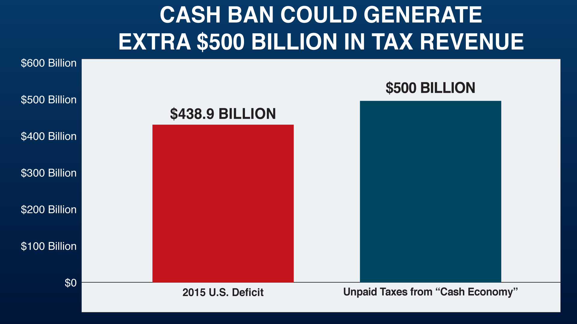
Oh, and I would consider that a good thing because people are using that money productively whereas if the government took its cut out of everything, that would be that much less that could be used by people who get goods and services that they want and need.
But this is another reason why the government is going to look to put blockchain in there, because it will be impossible to escape the tax dragnet with no cash to trade. It will be barter or use Fedcoin.
Actually, is that a good thing for the economy?
No, it’s a bad thing for the economy because people that are dealing in what’s called the underground economy are actually providing useful goods and services that if the government extracts its 30 or 40 percent in taxes, which they will be able to do now with Fedcoin, is going to hurt the economy, not help it. It will help the U.S. government, but that’s different from the economy in America.
Dr. Ron Paul, the former presidential candidate and 22-year Congressman is a friend of yours Doug, and he said that the cashless society is the IRS’s dream; total knowledge of and control over the finances of every single American.
Oh, I completely agree. Ron Paul is one of the few decent people that have actually circulated in Washington in recent decades. He is completely right. This is an extremely dangerous development for the average American.
So how is the Fedcoin different than the digital money we already own in bank accounts?
Well, right now those dollars are a liability of the bank… The Fedcoin is different because it’s not a liability of a commercial bank; it’s a direct liability of the Federal Reserve… number one.
Number two; it’s going to use blockchain technology which makes it totally trackable unlike dollars today. So those are two huge differences. It’s going to be sold as a safety thing because blockchain is much harder to hack than conventional digital technology. So this is another reason why they’re going to want to go in this direction; it’s for your own safety.
That’s a pretty scary thought… with the Fedcoin you are talking about no privacy at all.
No, zero.
That’s scary.
Well, not only that, but as an innovation, it’s much more convenient for them to create them, to debit them, and credit them. They’re really going to be in control of everything at that point. At least now your dollars are good outside the U.S. They are deposited in banks; you can get cash for them. If they take this to the next step during the next crisis… it's really complete control… these people believe that government control is the solution to a problem that they've created.

Sorry, You Can’t Buy This…
So the privacy; out the window with Fedcoin.
I read somewhere that they have a way of controlling how digital currencies – where they can be spent or what they can be spent on. Is that an element of control that the feds could possibly put into this new currency?
Of course. The computer can do anything.
When you take your Fedcoin via your smart phone or – this is rather shocking, but the next step, instead of a smart phone is everybody has a chip. A lot of people will like it; hey, I've got a chip. I can't lose my wallet. I mean, it's all right here. I mean, I'm permanently identified. It's very convenient. It's very stupid from a personal freedom point of view, but at that point, it can be used under this scanner; can't be used under this one.
It's all computerized. It's nothing. It's not a cosmic breakthrough at this point.
So Doug, this blockchain technology you've said is going to give the government incredible control. Can you give me an example of what you're talking about?
It's like an anti-cash. If I've got a $100 bill in my wallet or a bunch of 10s and 20s, I can spend them on anything I want with anybody I want and nobody knows.
With blockchain, I can only send that money to somebody else who's got a receptive smart phone or chip and they know exactly who's getting the money and what it's being spent for. It can be programmed so that certain transactions can't take place or transactions with certain people or stores or whatever. So you are pretty well blocked in.
I mean, for all I know, they might decide that, under your Obama Care or whatever comes of that, after it; you're too fat. You can't buy sugar, but if you can't buy sugar, who can buy sugar? I mean, how are you going to pay the other person to buy sugar if you want sugar?
You want ammunition for your gun? Well, maybe you can't buy it. How are you going to get it? How are you going to pay for it?
This is a real personal freedom problem and it's going to be sold to the American people under the guise of convenience and safety and fighting drugs and fighting theft and fighting crime and fighting terrorism and all the usual nonsense. But it's going to be devastating to our freedom and economic progress in this country.

“Unintended consequences…”
I can see how it might be sold, for example, if you limited, to say, a 16-year-olds Fedcoin account from buying alcohol. I mean, that could be sold as a real benefit; we can enforce the liquor laws…
Well, sure you can disguise a lot of things as benefits, but how is a 16-year-old going to get something that he or she wants if they can't buy it? Maybe they will have to barter. I don't know; maybe instead of buying something, maybe they will sell their body in order to get something. You'll have to barter to get around using Fedcoin. So there's all kinds of unintended consequences.
Well, I know with the food stamp program already, there are certain prohibited transactions. You're not allowed to buy liquor with food stamps. You're not allowed to say, spend your money – your electronic debit cards in strip clubs. I know that's a law in some states as well. So this just seems like a further extension of government control on individual behavior.
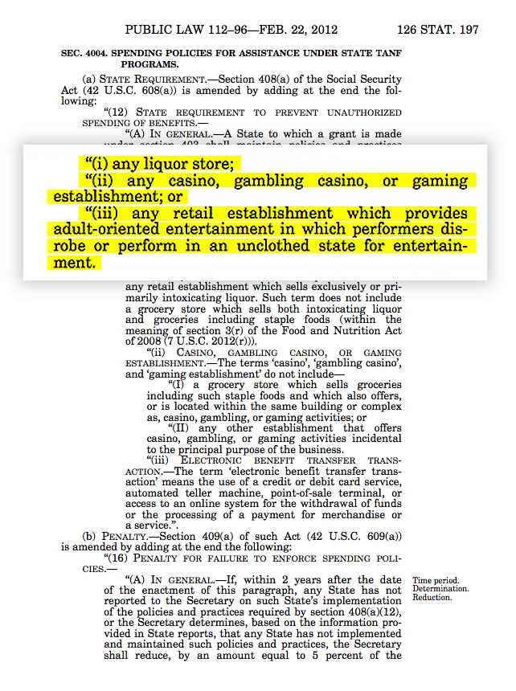
Absolutely. They will be able to prohibit anything without even passing a law quite frankly. If your Fedcoin smart phone or chip isn't programmed to let you buy that, how are you going to get it? You don't have cash anymore.

Forget the 2nd Amendment
Yeah, so who needs a gun registry, right?
Well, exactly. So no point in dealing with all these pesky Second Amendment laws at that point…
This is sounding very Orwellian and I just wonder how – when the Fed launches this thing, how are they going to sell this to the public? What's the pitch on this? I mean, what –
They will sell it as convenience.
Okay.
It's easy. They will sell it as security; you can't lose your wallet. Safety. They will sell it as patriotism; helping the government get the economy back under control. And the average person basically does what he's told.
I mean… even using the language of the government to – instead of inflation its quantitative easing. No problem. I mean, people – the average guy, I'm sad to say, has so little grip of basic economic theory. I'm afraid that that's true all the way up to the people in the very top echelon of the Federal Reserve; but they can really get away with anything at this point.

Social Security 2.0
You know, back in 1968, a guy named McGovern ran for president of the U.S. and he came up with a cockeyed idea. He was a Democrat of course.
His idea was, we ought to deposit $1,000 in everybody's bank account to stimulate the economy. Well, it was a laughingstock thing back then. But now, a lot of well-known, legitimate economists, are saying we ought to have a guaranteed income for everybody in the country.
And something like a new currency, a Fedcoin, issued directly by the Fed where you don't have to trust the bank which may be bankrupt…Something that could supplement Social Security…
Well, not everybody has a bank account with a commercial bank today.
Right.
But everybody's got a Social Security number and they could all have an account directly with the Federal Reserve which people think, hey, that can’t go bankrupt. They actually make our money.
It would be quite easy to reach out to everybody on their smart phone and give them a Fedcoin account with the Federal Reserve and distribute the helicopter money in a fair way.
So Doug, it sounds kind of like Social Security 2.0.
Well, that's very much the case.
It's following up a massive disaster; Social Security is a Ponzi scheme, and why not follow it up with an even bigger one. Social Security itself is bankrupt. I don't know where they're going to get the dollars to pay that off.
So perhaps they can do an arabesque around the problem by issuing a Fedcoin account to everybody to substitute and keep down the number of dollars by having an alternative, parallel currency…
Where these obligations can be made good directly with accounts with the Federal Reserve—the issuer of the currency—ruling out bankrupt insurance companies, bankrupt commercial banks, for that matter, a bankrupt Social Security system…. What are they going to do?
At this point they've shot all the arrows in their quiver.
They've printed up huge amounts of money. They have reduced interest rates to zero. In fact, at this point is about $13 trillion of government bonds around the world that have negative interest rates where, forget about the inflation losing value, eating the value of your money, you have less money at the end of – it's absolutely insane. It's bizarro world where things are turned upside down.
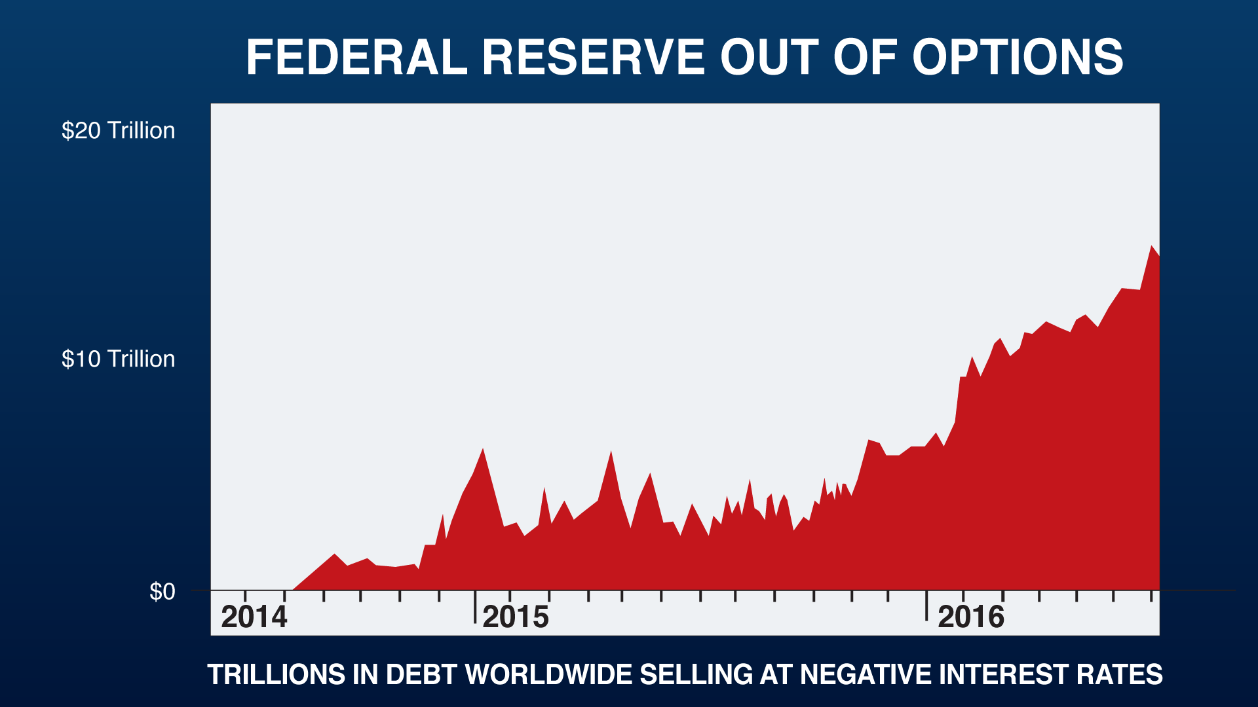
It's like the last – the last arrow in their quiver that I can see at this point.
So Doug, is this Fedcoin something that is going to replace the US dollar or will it exist alongside the US dollar so you will in effect have two currencies?
This is the $64 question. It's hard to say how it will work.
To start with, I suspect it's going to be a parallel currency. Perhaps usable just within the U.S. which, in effect, would be a form of foreign exchange controls even more effective than the inability of Americans to open up foreign bank and brokerage accounts today. But in the event of a serious problem with the dollar, for a lot of reasons, or the banking system, for a lot of reasons, it provides a parallel currency; an alternative directly dealing with the issuer itself. I think it's a near certainty that they're going to do something like this and soon.

Proof?
Doug, this is an interesting theory, but is there any evidence that the Fed is actually looking into this at this point?
There actually is. There have been a number of statements by everybody from Janet Yellen on down that this blockchain technology which is the back of Bitcoin; they consider it viable. They want to use it and this is unusual in a way on the part of the government.
Usually when a technology, a new technology of any type, comes out, whether it's the horse or gunpowder or the printing press, the government doesn't like these things; these innovations because they take power away from whoever controls it. The establishment –
The status quo, right.
Exactly. Changes the status quo and gives power to the common man. All these things have liberated the common man. The computer revolution, the Internet, is a perfect example of this. But in this case, the situation is so serious I think the government wants to co-opt this technology; to get in front of this technology.
Since it's already been legitimized, the idea of Bitcoin and blockchain technology, I think the next step is that you're going to find the Federal Reserve itself offering Fedcoin, which is very convenient for them because with that, they can designate exactly how those Fedcoins can be spent.
They know exactly who gets them, what they're used for, and so forth. If there is ever a serious problem with the dollar, for instance with the trillions of dollars outside the US flooding back into the US, it can act as an alternative currency which, at least for a while, will have some semblance of confidence.
So it sounds like a way to shore up the money system…
It's pretty unstable…
They've used all the monetary tools that they know exist. This is the only thing that I can think of to further shore things up.
They've been talking about it. Nobody's been listening. It's an outrageous idea, but it's going to happen. It gives the government more control and that's what the government needs and wants and thinks is a good thing quite frankly. No, of course they're going to do this. You've got to get ahead of the situation.

Yellen’s Secret Meeting…
Doug, we will talk about how you can protect yourself in a moment, but first, I want to get a sense from you for when this is going to be happening. Surely we're talking multiple years, maybe even decades before this comes about.
I think not Bob.
I think that since we are going into the trailing edge of this gigantic financial hurricane now… So we're not talking about decades or years. We're talking months or for that matter—depending on when somebody views this—it could be a matter of weeks. I mean, there is a certain amount of urgency. Not just importance, but urgency in doing this.
Look, it's happening right now…
In Canada, they have something called Project Jasper, which is their own version of this. The Chinese have announced that they're planning on a blockchain type currency, the same thing… They have said that they wanna see this happen “as soon as possible.” The British have made the announcement along these lines.
This is seen as a worldwide solution; part of the globalist solution to problems.
You don't see this widely reported in the media, but it's happening all around us at this point. So it's gonna happen here. Look, in June 2016, this year, Janet Yellen and dozens of other central bankers met with the top experts in the blockchain area, including the people that are in back of Bitcoin at this point. It's happening now.
The technology is there. But my question to you is; wouldn't it take a long time for an infrastructure to be put in place to allow the Fedcoin to be distributed?
Actually, the infrastructure is there right now.
It's there right now?
In other words, if the U.S. government needed currency to redeem people's demands for their money at a bank, they couldn't possibly print up enough currency quickly enough. That's out of the question. However, today almost everybody, except the very bottom of society, everybody has a smart phone and the blockchain technology has been active and used now for a decade.
Now Doug, just so I understand what's going on here... So the Fed has run out of policy tools. They've printed trillions of dollars. Interest rates are basically at zero and soon they may have to go negative in an effort to stimulate the economy, but they won't be able to do so without banning cash. Then they're going to come up with a new currency; a Fedcoin that traps people savings. Essentially, this could be the ultimate confiscation and control tool. Do I have that right?
Bob, you are absolutely right.
The most important thing to remember is that the paper dollar, the $100, the $50 bill, currency itself is on its way out. It's going to be replaced strictly with digital money as is happening in other places in the world right now. This has got very serious consequences for you on all levels. So plan your life around that.
So Doug, is this going to be a total reset?
Bob, I hate to say something that sounds radical and even outlandish, but this could not just be the biggest things since the last depression; this could be the biggest thing since the Industrial Revolution with all kinds of consequences.
It's going to be a massive storm with unpredictable consequences. I hope that doesn't happen, but I'm not even so much worried about the financial and economic aspects of this as I am the social and the political and the military aspects of it. This is one of these turning points were things could get completely out of control.

How to Protect Yourself:
An Action Plan
Now Doug, let's move on to what people can do to protect themselves.
You've been studying currencies and their effects for 40 years. Because you've lived in 10 different countries and visited 175, you've personally gone through three, four currency crises before. You've seen the ravages firsthand, but you've also seen the flipside how if one is carefully prepared, you can actually come out way ahead. In fact, in the '80s, you took advantage of a… crisis in China and turned $30,000 into $950,000.
Now, the research firm you founded, Casey Research, just put out this new book that outlines your four step plan to surviving a currency crisis. It's called, Surviving Fedcoin: How to Protect Yourself and Profit from the Coming Currency Change. …you are making this book available for free to everyone at home. Let's go over the plan…
Well, I'm not trying to be an alarmist. I'm just trying to anticipate where the current trend is going. All the current trends I'm looking at are accelerating in one direction. There's a four-part program that I've put together…

Step 1: Liquidate
First of all, you've got to look at where you are in the world today. What do you own? Where do you live?
If you have two cars, three cars, a bunch of flat screen TVs, too much junk around the – the first thing is, liquidate. I think that you should take everything that you don't really, actively need or want and get rid of it. Get fighting fit. Get slim. Turn it into cash. It will liberate you psychologically. It will liberate you financially.
It's also true of stocks that might be in your portfolio that your broker put there and you forgot why you own them. And certainly bonds which are in a bubble; worst thing you could own right now.
So liquidate is the first thing.
So Doug, I understand in the book there are four sectors in the stock market that you specifically think investors should be avoiding as we move forward…
Yeah, you're absolutely right. There are some things that you should avoid like poison. On the other hand, you can take advantage of them as a speculator by going short on these things. They crash; you win.
Okay, that's step one.
Step one.

Step 2: Create
Step two?
You're going to want to create. What do you know? What people do you have contacts with? What knowledge can you sell to others? You've got to create. It's not enough just to have the assets that you have… You've got to look at the job that you're in. You've got to look at your entire life situation. That's what I call the create stage.
But perhaps from our point of view now, the most important parts… are the “consolidate” and “speculate” parts of this.

Step 3: Consolidate
By consolidate I mean, look at where you should be.
Your financial assets, stocks, bonds, your IRA, your HR10 plan, your bank accounts, and so forth; get them in the right places; in the right kind of assets. Take control of this because most people just flow it along one day to the next and then all of a sudden, 2008 happens again except this time different and worse and they are in the wrong position.
So after you've liquidated, you've got cash, you've got less liabilities, less obligations. Now you're going to consolidate and get things together; get organized to get off on a new foot.
So consolidation means taking the cash that you got in the liquidation stage and I would do two things with it. I would keep a lot of it in cash and I would buy gold and silver coins in your own possession; physically that you own.
Doug, expand a little bit your thinking on why cash is so important right now…
I mean, if you don't want to be completely transparent… to use a currently fashionable word… to these people that want to control your life, cash allows you to remain anonymous.
The ability to transact in cash gives you privacy. Privacy is one of the big differences between a civilized society and a primitive society. In a primitive society, in your little dirt hut village, anybody can look through your window or pull back the flap on your tent. You have no privacy. Everybody can hear everything; see anything. This is one of the marvelous things about modern civilization is that you have privacy.
One reason for buying things with cash now is that it may not be possible to buy those things with cash later. I'm not sure what percentage of the population owns a gun, but I think that any free man should be in a position to defend himself… better buy them now while it's possible to do so for cash.
Right.
So this is a very, very serious thing not just financially, but from a personal freedom point of view as well.
So Doug, how much cash do you suggest keeping on hand?
Well, one of the problems in the U.S. at this point is that the average guy can't even lay his hands on $400 overnight if he needs it.
You might recall an article in Atlantic Magazine a few months ago. I thought it was interesting because it was a mainstream magazine. It said that the average American today, or by that they meant about 40% of the country, would have to borrow money to handle an unexpected $400 expense.
Yeah, I read that. That shocked me as well.
That's pretty close to the edge…
So the whole country is very illiquid. When everybody else is illiquid, you want to be liquid. So I think that you want to keep several thousand dollars. And if you're watching this right now, that should be doable…
Doug, you're suggesting that people hold on to several thousand dollars in cash, but what happens if the $100 bill is banned?
These things are just going to go out of circulation, but they will still be accepted for a good long time and you might be better off not having 100s anymore, but having 50s, 20s, and 10s. Now it's true that's going to be a bulky little package, but that's the way things are going.
In Argentina, when you bought or sold a house, you did it with pesos. When you bought or sold a house, you would have a suitcase full of pesos which would be counted out at the notary's office. So I hope we don't get to that here in the U.S.
Doug, I understand that the book contains, or reveals, the best place to store cash which I guess will be a surprise to many readers.
Well, there are clever places and not so clever places to keep actual currency, cash. So we go into those things. Some of them are not very obvious at all.
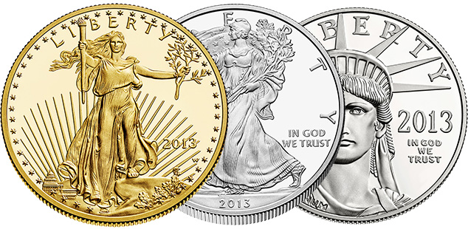
Let me add something about consolidate; I think at this point it's important that you build your portfolio of gold and silver coins; physical coins in your own possession. I think that's very important. Most Americans don't have any gold or silver.
I would much rather have, if I'm going to keep anything in my pocket, a gold coin like this one. It's not gonna lose value, and relative to this paper, it's going to go up.
You're going to want to own a lot of gold and silver coins; as many as you can afford in your own possession because they are like the anti-Fedcoin.
Gold and silver are the only financial assets that are not simultaneously somebody else's liability and they are not digital. So they can't be controlled and tracked the way Fedcoin and digital currencies can be. So that's why they are an essential part of your consolidate position. As well as having some actual paper cash.

Another Gold Ban?
So Doug, if we go the Fedcoin route, you're suggesting that individual investors get their hands on gold coins and silver coins. But isn't it possible that the US government will confiscate gold the way they did back in 1933?
Well, that is one of the problems that we are dealing with now; it's that the U.S. government can and think that they should do anything that they want. So sure, that's possible… But that's all the more reason when you buy your gold to buy it with cash so that there is no record that you own it.
You reveal in the book one last place where you can buy untraceable gold.
That's right and you ought to do it now—beat the last minute rush. Do it while it's still possible.
I'm not so worried about the government confiscating a few gold coins or even a lot of gold coins from individual citizens because Americans that own gold today generally own it through ETFs. And most of the gold that those ETFs own is paper gold traded on the futures exchanges. So if the government really wants to confiscate gold this time, they're going to do it through publicly traded vehicles like ETFs and the futures exchanges.
I don't think they're going to go rummaging through people's individual houses looking for a few gold coins. But that's why you want to own gold coins in that form, in your own physical possession as opposed to some paper product through your broker.
So Doug, I understand that the banks are actually following your advice. They are loading up on physical gold. I understand that HSBC has bought four tons. Goldman Sachs has bought three tons. So they're loading up on the physical stuff; not on the ETFs…
And it's not only commercial banks like them. The central banks of advancing countries like China and Russia, India, Thailand; these central banks are all buying gold as well.
You might wonder; Why are they doing that? It's because gold is the only financial asset that is not simultaneously somebody else's liability. In a world that is as head over heels in debt, as this one is, that's critical.
No counterparty risk.
Exactly. There's no daisy chain to break with derivatives and so forth.
Doug, this Fedcoin seems inevitable to me after our conversation here… but… let's just assume that it doesn't happen. Can you still make a case for owning gold?
Oh, absolutely. I mean, I think Fedcoin is going to happen and that's going to accelerate all these things, but I think that you're going to see gold in this next cycle; $2,000, $3,000, $5,000 an ounce…
It's going to be a seemingly insane number. There is going to be a panic into gold and it's going to happen not just from greed as people see it going up relative to the dollar, but it's going to happen from fear as well and it's going to happen from prudence in addition. So you're going to have three emotions acting on this gold bull market at the same time.
Doug, I understand that the book reveals the top four gold coins that the novice investor should consider purchasing.
Yeah, that's true, and we also cover some more obscure, but in many ways, more interesting types of gold coins as well. All with very low premium about their slated dollar value.
You also go into the cheapest way to legally buy gold coins in the United States.
Like almost anything else there are smart ways and not so smart ways to do things. So we absolutely try to cover the practical aspects of all this in addition to the theoretical possibilities we've been talking about.

Recent Seizure…
So Doug, are you suggesting that people buy gold now or is this something they can do in a few months?
I think it's going to go up several hundred percent from here. So the time to buy it is now. Don't delay. Don't look for a retrenchment. If the retrenchment occurs, use it to buy more. But no, you want to act now. You want to buy now because it may become impossible to buy gold in the future.
I mean, this recently just happened in Sweden. The largest gold dealer in Sweden, their bank accounts were frozen for no reason other than the Swedish government no longer wants to see gold purchased. This is likely to happen other places….
We are trapped increasingly like lobsters…The government never controls itself. It only tries to control its subjects. That's the problem.
So this new environment that we are going into is going to require a dramatic change in the way people invest their money.
Not only that Bob, but I think it's going to take a huge change in the way they think. People have been hardwired to think in terms of the stability that used to be, but that stability is gone. So they're going to have to change, not just their investments, but their whole mode of thinking….
They've been guided down the primrose paths by the people that control the Treasury Department and the government and the presidency. I mean, if there was any justice in the world, many of these people would be hung from lampposts by their heels…
It's like a GPS system that's gone haywire; you can't believe the directions anymore.
No, you can't.
In a time like this, the markets are going to be going up and down like an elevator with a lunatic at the controls. That's bad news from the point of view of most people because it's a very unstable, unpredictable situation.

Step 4: Speculate
So you've got to learn to think like a speculator.
That's number four; speculate. Which is to say, capitalize on these politically-caused distortions which we are going to see in the market. Because if the stock market falls 80%, that's a disaster if you own stocks… But if you saw it coming and you can short the stock market…where most people are losing 80%, maybe you are quintupling your wealth in the same time. The same thing in commodities, bonds, real estate, and so forth.
It's increasingly less possible to invest in the manner that Warren Buffett has made famous. It's no longer possible as they are in the process of destroying the currency.
This is a time when markets are going to be going up and down chaotically. It's the time of the speculator. You have to change your mindset. Now, that's bad news for most people…
The good news is that it's going to present some tremendous speculative opportunities where instead of, like most people saying, all right, I'm going to take $100 and hope to earn $10; risk $100 to get $10. In this environment, a speculator is going to be able to take $10 and hope to gain $100.
So that's the environment we are moving into. If you can change your mindset, they're going to be tremendous opportunities.
Give me an example…
One of them which I specialized in for many, many years is junior gold mining stocks. They're the most volatile class of securities on the planet bar none.
As we speak right now, they are very cheap and there is every reason to believe they're going to go on a manic run in the future. So this is one area I like a lot. But I watch all the markets all around the world and all the stocks here in the U.S. So there will be many others, but that's one I will draw to your attention at the moment…
Which are not good investments typically but are fantastic speculations from time to time.
And we're in one of those periods right now, in your estimation.
We are. Since – since 1971 when the dollar was taken off the gold standard, there have been six or seven massive bull markets in gold stocks where they'll run up 1,000%, lose 95% of their value, run up 1,000% again. And right now, they've just come off one of the worst bottoms in the last 40 years. And I think that they're gonna go to one of their highest peaks in history in the years to come.
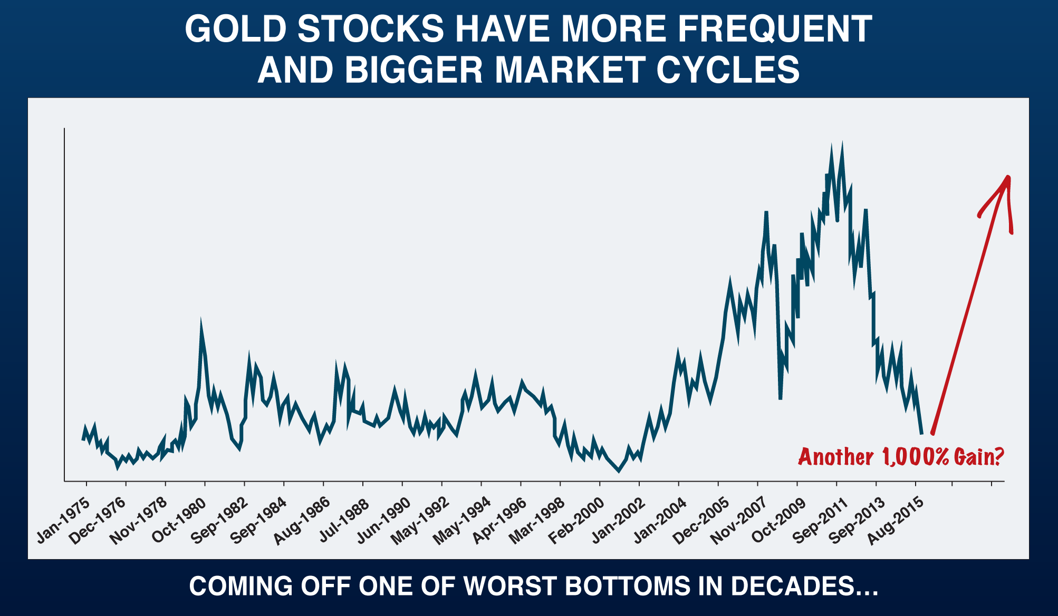
If gold does what I think it's going to do, the stocks could go, as a group, 1,000%—which they've done many times in the past incidentally. Some individual stocks could easily go 50 or 100 times which, incidentally, many of them have done in the past.
So I think that these last two things that I mentioned are very important. To consolidate with gold and silver and learn to speculate and I think at this point, one of the surest speculations, nothing is certain, is junior gold mining stocks which are very cheap as we speak.

Free Book
Thanks Doug. Now, you founded Casey Research, your investment research firm, almost 40 years ago. And each month your lead analyst, E.B. Tucker, writes, with your oversight, The Casey Report. I understand this is your main publication that is currently read by tens of thousands of readers each month.
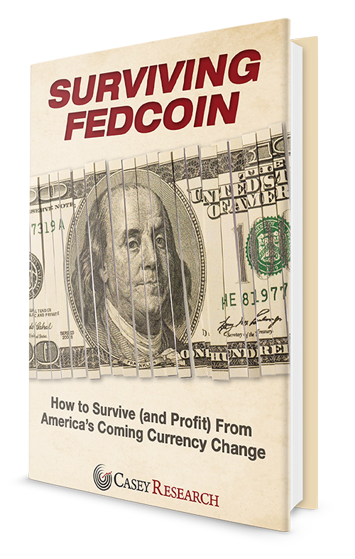
As part of this special presentation, not only are you letting readers at home get a free copy of the new book your research firm's just put out, Surviving Fedcoin: How to Protect Yourself and Profit from the Coming Currency Change, you are also letting [making] people at home try out a one-year subscription to The Casey Report with no risk and at a substantial discount.
We've talked about just a small part of what is almost sure to happen and only in the near term. But that's just step one. There is a great deal more to be said. The Casey Report is the best place to “track the rest of the story,” as they say, and E.B. and I will stay on top of the situation as it unfolds and will tell you what we believe you should do.
Thanks Doug.

Closing Thoughts
Today Doug Casey revealed what may be at stake for Americans if a new digital currency like Fedcoin is implemented.
It could mean the end of financial privacy… Total government control… And even the outright confiscation of our savings.
But… his team at Casey Research isn’t standing still, waiting for the catastrophe to hit.
They’ve put together a special “Fedcoin Survival Kit” to reveal the steps they’re taking right now to protect their savings. It’s a roadmap they believe everyday Americans can follow to not only ensure they keep what’s theirs… but also come out ahead.
The first part of the kit is their brand-new book, Surviving Fedcoin: How to Protect Yourself (and Profit) from America’s Coming Currency Change.
Inside the book, you’ll discover…
- The single most important phone call you can make—it could save you up to $25,000 if you own stocks…
- The four most dangerous investments in America right now…
- The last (and surprising) place to buy “untraceable gold” as well as the top 4 coins to buy
- 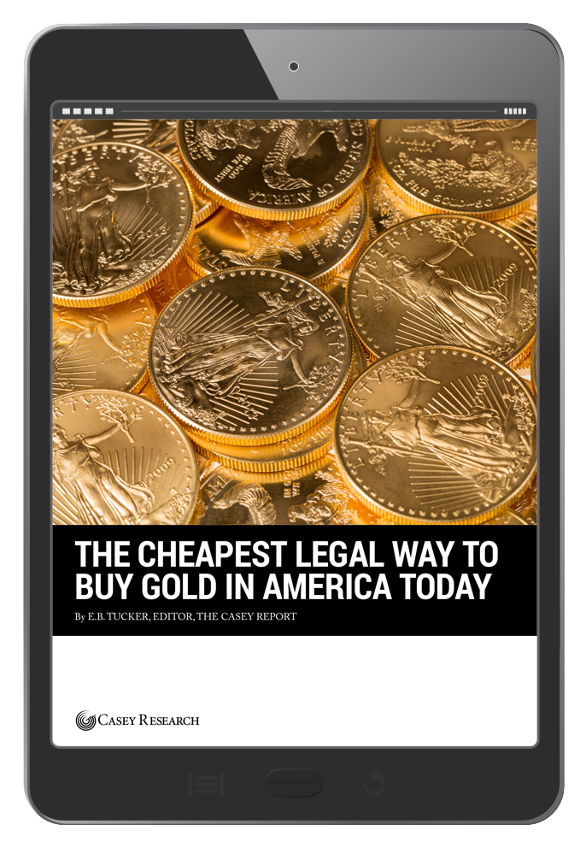
The #1 place to hide your money
- The 3 best “crash-proof” companies to add to your portfolio right now…
- As well as the #1 alternative currency to own for surviving a currency crisis.
Next is a special report on The Cheapest Legal Way to Buy Gold in America Today. This loophole, which lets you save up to 87% on gold coins, is a Casey Research exclusive.
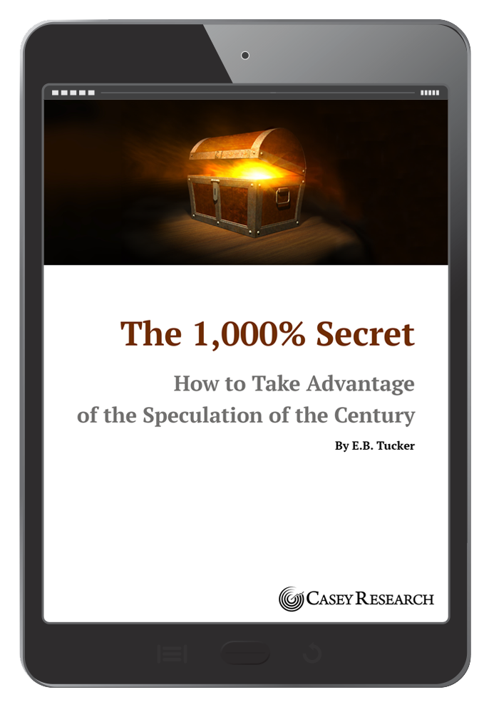
Then there’s The 1,000% Secret, the special report on how you can take advantage of the “Speculation of the Century.”
It’s no secret Doug Casey is one of the best speculators on earth, having made enough money to own a penthouse in Buenos Aires, beachfront property in Uruguay, and a $20 million ranch in Aspen. In the 1,000% Secret, you’ll learn about the one specific investment the Casey Research team believes will go up ten-fold in the next 2-3 years.
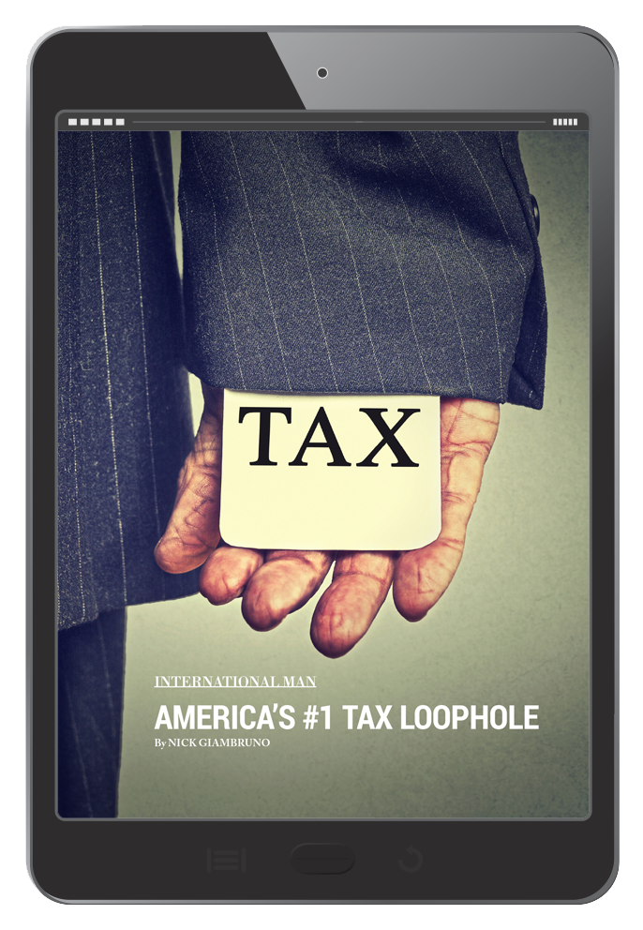
Last is the special report on America’s #1 Tax Loophole. This details a unique, 100% legal way for most people to drastically reduce their tax bill—without having to move outside America!
At the bottom of this presentation you’ll find a special link. When you click this link, you’ll find out how to claim the full Fedcoin Survival Kit—including the new book on Surviving Fedcoin and the 3 special reports—for free.
There may be little time before this currency change takes place. And, remember, Doug Casey has a history of being right on shocking predictions. He predicted 9/11, the Dot Com collapse, and the housing crash… and as one journalist said, “Casey anticipated the (Savings and Loans) collapse… and the end of the gold boom.”
After listening to Casey, it seems clear to me the Federal Reserve has run out of options, and something like Fedcoin will be upon us soon. I recommend you take the proper steps to secure and protect your family’s finances today, while there’s still time.
Just click on the link below to get started. You will be taken to a secure page where you'll be able to review everything before confirming your order.
Sincerely,
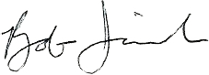
Bob Irish
November, 2016
Click Here to Claim Your
Free Fedcoin Survival Kit

