[My summary of the first article: Well written, sensible, very good. But nothing new to me on whether to short long-term Tbonds. Consider skipping to second article.]
Jay Kaeppel, Optionetics.com
December 3, 2008

“There’s always a bull market somewhere.” I love to use that phrase and to emphasize that one of our jobs as investors and traders is to do the work necessary to find and take advantage of today’s bull market. Sometimes it’s the overall stock market itself, and all one has to do is buy an index fund and go along for the ride. Sometimes it’s a particular sector of the market (health care, energy, etc.) and a sector fund will do the trick. Sometimes the bull market is in the bond market. Or gold, or commodities, or real estate. And for the full extent of my investing lifetime this has pretty much held true. Until now. …….Of course, you probably don’t need me to tell you that. Chances are you are already aware of this fact. ………….
In Barron’s Financial Weekly, Tom Sullivan noted in his “Fund of Information” column that there are 11,585 U.S. and International equity mutual funds in the Morningstar database. And incredibly, every single one of them is down for the year! Go ahead and let that sink in for a moment. The upshot is simply that if you invested in the stock market this year there was really - literally - no place to hide.
……….. In fact if the stock market were to rally strongly for the next several months - along the lines of the “typical” November to May rally…….., the vast majority of investors are going to “breathe a sigh of relief” and lapse back into the standard “the stock market always goes up or always comes back” way of thinking. This may lead to a great deal of long-term frustration ………………….

The Only Bull Market In Town - While it Lasts
Okay, the truth is that I was slightly holding out above. There actually has been a bull market somewhere. Treasury bonds have enjoyed an excellent run. Not corporate bonds. Not GNMAs. Not muni bonds. But as you can see in Chart 1, t-bonds bottomed out in June and have advanced since, rallying especially sharply in the past month.
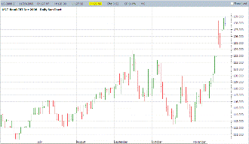
Chart 1 - December T-Bond Futures (also known as “the only thing going up”)
click here for larger view
Now on one hand this makes perfect sense. A weakening economy typically leads to lower interest rates and lower interest rates are the driving force for the t-bond market. At the same time this latest advance smacks of a fear driven “flight to quality,” as investors seek the perceived safety of treasury-backed bonds. This has happened on other occassions in the past. Historically, once a fear driven flight to quality buying panic in T-Bonds is over, the advance peters out. Consider the data presented in Chart 2. This chart was put together my [by?] Tom McClellan, world-class market analyst and Editor of the McClellan Market Report. What is interesting to note is how similar the current action of the t-bond market is to several other previous “blow off” tops - specifically, 1998, 2001 and 2003. There is no way to know for sure if that will be the case this time around except to wait and see.
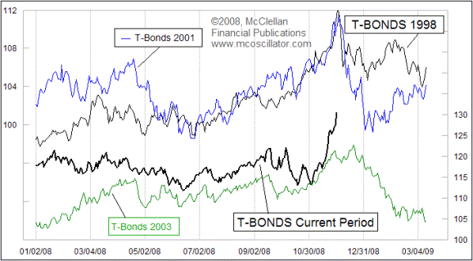
Chart 2 - Previous T-Bond buying panics and today’s market; Are T-Bonds “blowing off”?
(Source: Tom McClellan)
As further evidence that the advance in treasury bonds has been driven primarily by “fear,” consider the fact that the rate of interest being paid on short-term treasury bills is now about 0.3%. As you can see in Chart 3, since 1990, short-term interest rates have plummeted from about 9% (denoted as 90 on the right hand side of the graph) down to approaching 0%.
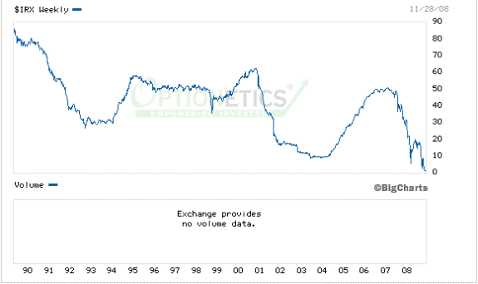
Chart 3 - Short-term rates - Headed for 0%?
To put it another way, investors are essentially lending money to the government for next to no return just for the privilege of having the government keeping their money safe. Ironically, that very same government is meanwhile actively in the process of trying to give much of that money away to every badly run and/or dying business and/or borrower with a sob story - with the notable exception of auto manufacturers (note to myself: if it becomes necessary to go to Washington to beg for money, rent a beat up old car, not a private jet).
In a nutshell, given the crazy nature of today’s markets, it is absolutely possible that long-term interest rates will continue to fall and that t-bond prices will continue to advance. Nevertheless, given the sharp run enjoyed recently by the long bond, those still waiting for the right opportunity to panic into bonds might want to wait for a meaningful pullback first. Then panic all you’d like.
Pure Momentum
On a number of occassions and in a number of different places, I have written in the past about a system I developed that I call “Pure Momentum.” Now it’s not really much of a “system” per se and the basic idea has been around for a long time so to say I “developed” it is perhaps a bit of an exaggeration. Nevertheless, in this business, trading methods seem to be held in slightly higher regard if you “developed” them and also if they have a catchy name. Also, the longer they have been around, the better. So let me reiterate that “many years ago” “I developed” “Pure Momentum.” Impressive, eh?
Okay, all kidding aside, the rules are simple:
- At the end of the month identify the Fidelity Select Sector funds that advanced the most over the previous 240 trading days and buy and hold those funds until the end of the next month;
- Repeat.
Now, historically this has been an excellent investment method. But how does it fare when the stock market – including every single sector – melts down? Well, there is some good news and some bad news. The good news is that as of September 30th, there were no funds to buy. In other words, looking back from the end of September there were no Fidelity Select Sector funds showing a profit over the previous 240 trading days. That was also the case at the end of October and November.
So the good news is that during the market meltdown of October and November, Pure Momentum was 100% in cash. So what’s the bad news? Simple: the market was lousy well before October and so far this year the return for Pure Momentum is -22.9%. Now, of course, one could argue that this is better than the 36% decline suffered to date by the S&P 500 Index. And this is true. Still minus 23% is minus 23%. The long-term results for Pure Momentum appear in Table 1.

Year | Pure Momentum % +(-) | S&P 500 % +(-) | Pure Mo. Versus S&P 500
1990 | (-4.7) | (-6.6) | 1.9
1991 | 74.7 | 26.3 | 48.4
1992 | 17.4 | 4.5 | 12.9
1993 | 24.9 | 7.6 | 17.3
1994 | 8.1 | (-2.0) | 10.1
1995 | 36.1 | 34.1 | 2.0
1996 | 17.9 | 20.3 | (-2.4)
1997 | 30.5 | 31.0 | (-0.5)
1998 | 23.1 | 26.7 | (-3.6)
1999 | 110.8 | 21.0 | 89.8
2000 | 18.2 | (-10.1) | 28.4
2001 | (-6.4) | (-13.0) | 6.6
2002 | (-14.1) | (-23.4) | 9.3
2003 | 24.0 | 26.4 | (-2.4)
2004 | 13.0 | 9.0 | 4.0
2005 | 33.5 | 3.0 | 30.5
2006 | 12.1 | 13.6 | (-1.5)
2007 | 20.6 | 3.5 | 17.0
2008 | (-22.9) | (-39.0) | 16.1
Average | 22.0 | 7.0 | 15.0
Table 1 - Pure Momentum versus S&P 500 Index
Summary
Uncertainty remains the watchword (“The Most Important Word for Investors in 2008”). What looks terrible may turn on a dime and rally sharply higher at any time. And what looks good today could vanish into the ether tomorrow. Now more than ever before, it is crucial to have or develop a plan - one with a keen eye towards risk management - and to follow it.
And FYI: relying on the stock market - or the government - to “bail you out” does not consititute a solid investment plan.
To search for previous articles written by Jay Kaeppel, please click here.
Jay Kaeppel
Staff Writer and Trading Strategist
Optionetics.com ~ Your Options Education Site

[Article 2 of 2 - my summary: Greg, this is pay dirt. This is the best discussion I’ve seen on FRNs Treasuries, & long term interest rates for Treasuries. You can skip down to “Isn't this extremely inflationary?” and start looking around. (This version is already commented by normxxx, so I will not use any red highlights.)]
Wednesday, December 3, 2008

Monetizing The Debt
Monetizing The Debt
By Axel Merk | 3 December 2008 [Hmm. I own some of the Merk hard currency fund. This should be good.]
Deflation won't happen here; at least not if Federal Reserve (Fed) Chairman's Ben Bernanke's plan pans out. Deflation is considered a persistent decline in prices of goods and services; in a speech in 2002, Bernanke outlined the steps he would take if the U.S. ever faced the threat of deflation. Deflation will suffocate anyone holding debt as the debt burden becomes more difficult to finance with shrinking income; in contrast, inflation bails out those who have a lot of debt. In our assessment, fighting deflation is the Fed's top priority now; the latest minutes from the Fed's Open Market Committee (FOMC) meeting state:
"Indeed, some [FOMC members] saw a risk that over time inflation could fall below levels consistent with the Federal Reserve's dual objectives of price stability and maximum employment. …the limited scope for reducing the [Federal Funds] target further were reasons for a more aggressive policy adjustment; …more aggressive easing should reduce the odds of a deflationary outcome…"
To understand how "more aggressive" easing is possible when interest rates are close to zero, a little background is required on how the Fed is "printing" money. Until a few weeks ago, the Fed's main tool to control interest rates was to manage the Federal Funds target rate by engaging in "open market operations"— to buy or sell short-term government securities, mostly Treasury Bills. These operations are based on the principle that banks have cash deposits as reserves to lend money.
For any dollar on deposit, a multiple number of dollars may be provided as loans; the basic principal of modern banking [being] that not all depositors will want their money back simultaneously. But, if they do, a 'run on the bank' that may occur in such a situation that would either result in the Fed coming to the rescue or the bank's failure. In addition, the Fed can "tighten"
monetary policy by selling, say, Treasury Bills in the open market.
[ Normxxx Here: This last has the effect of lowering the price of all Treasury bills in the market (since they are now less scarce) and hence of raising interest rates (since the bills pay out a fixed dollar amount after issue). By making cash less available in the market place for these bonds, the cost of borrowing, i.e. interest rates, goes up. Conversely, the Fed can buy Treasury Bills, providing the market with increased cash, aka, 'liquidity'. By making bonds scarcer, their price goes up and, conversely, their yield goes down. ]
This world was shaken when Congress, as part of passing the TARP bank bailout program, authorized the Fed to pay interest on [[on the reserve deposits of member banks': normxxx]] 'deposits' at the Federal Reserve. Theoretically, even if the Fed provides massive amounts of liquidity, interest rates should not go to zero as banks should always be able to go to the Fed and receive interest on deposits there. The idea is that the banking system could be flooded with liquidity while ensuring that [[short term: normxxx]] interest rates don't go down to zero.
Fed officials are fairly miffed that the market hasn't quite worked that way. Short term Treasury bills have hovered close to zero, even though the 'official' target Federal Funds rate is at 1%, and the interest paid on deposits at the Fed is at or near 1%. Note that many of the new programs the Fed has introduced have little or no historic precedent; as a result, the programs may not be effective or may have unintended consequences. [[They may even prove counterproductive!: normxxx]]
Aside from paying interest on deposits, the Fed, using the above model, can do a lot more to provide "liquidity". Namely, the Fed is not limited to buying and selling T-Bills, as recent announcements have shown. The Fed is free to buy just about anything: mortgage backed securities (MBS), car loans, commercial paper, to name a few. (The Fed could also buy typewriters, cars, domestic or international stocks— anything.) In an announcement on November 25, 2008, the Fed said it would buy up to $600 billion of mortgage-backed securities issued by the government-sponsored entities (GSEs) Fannie and Freddie.
For example, a bank would like some cash, but cannot find a buyer for the mortgage-backed securities it holds. The Fed may step in, buy the securities and provide the bank with the cash. The bank in turn is now free to lend the money— some multiple of the cash received.
How does the Fed get its money? It doesn't need to borrow it; it merely creates an entry into its balance sheet. All the Fed requires to "print" money is a keyboard connected to a computer. The difference between the Fed and the Treasury issuing money is that the Treasury needs to get permission from Congress before selling bonds. In this context, it shall be mentioned that physical cash (coins, bank notes) are entered as liabilities on the Fed's balance sheets; they are rather unique liabilities, however, as you can never redeem your cash: [[Treasury bills have not been redeemable since 1933: normxxx]]. [I think normxxx is way off, on that. -FNC] While it is possible for central banks to remove cash in circulation, they are not obliged to do so.
Until recently, the Fed would only temporarily park non-government securities on its balance sheet, A bank would typically receive a temporary, often overnight, loan for depositing top rated securities with the Fed; these "swap agreements" were traditionally intended for very short-term loans, but the crisis has led the Fed and other central banks around the world to engage in 60, 90 day or even longer agreements. Since late September, swap agreements have been supplemented by outright purchases[[ of securities: normxxx]].
When the Fed issues [[new: normxxx]] cash [[ie, not borrowed from an existing holder of dollars: normxxx]] for the debt securities it acquires, we talk about "monetizing the debt". This can be taken yet a step further, although this last phase has not yet been implemented. When the government needs to raise money, the Treasury issues debt in form of Treasury bills and Treasury bonds.
To keep the cost of [[intermediate term and long term: normxxx]] borrowing for the government low, the Fed itself may step in and buy Treasury bonds. Whereas traditionally, the Fed actively manages short-term interest rates only, by buying and selling short-term Treasury bills, the Fed may also buy, say, 10- or 30-year bonds. It's a wonderful funding mechanism: if the Treasury needs to raise cash, the Fed could provide it as needed.
Isn't this extremely inflationary? Quite possibly, quite likely, but not necessarily is the short answer [[at least, not in the short run: normxxx]]. First of all, the Fed has the ability to "sterilize" its debt monetization program. Take the situation where the Federal Reserve buys "highly rated", 'toxic' assets from the bank, but doesn't want the bank to go out and lend a multiple of the cash it receives. What the Fed can do is to sell the same bank, for example, some Treasury bills to "mop up" the extra liquidity. This would have the impact of improving the bank's balance sheet without supercharging the economy.
Indeed, in late September the Treasury instructed the Fed to do just that. They even invented "Supplementary Financing Program" (SFP) bills for this purpose. On the chart below, the dark blue line indicates the cumulative growth in the Fed's balance sheet, i.e. the Fed's "printing of money"; the light blue line shows the cumulative activity to mop up the added liquidity by selling SFP bills to banks. The Fed's balance sheet has grown by about $1.2 trillion to currently over $2 trillion. Dallas Fed President Richard W. Fisher said the Fed's balance sheet may reach $3 trillion by January.
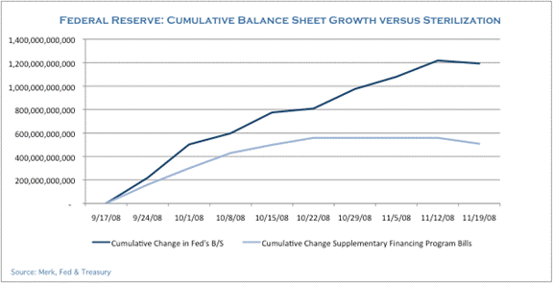
As even the untrained eye can see, the Fed has not mopped up all of its liquidity injections; indeed, as of October 22, 2008, the Fed seems to have all but abandoned the program. In our assessment, at least for the time being, the Fed is not interested in mopping up, but in adding massive amounts of liquidity.
Well, isn't that extremely inflationary? It depends on your definition of inflation; if it's a growth in money supply, then, yes, this is already extremely inflationary. But so far, this hasn't translated into higher price levels or even higher long-term inflation expectations as measured by the spread of 10 year TIPS versus 10 year Treasury bonds; TIPS are inflation protected Treasuries that provide compensation for increases in the consumer price index (CPI); it is this spread that the Fed is most concerned about when gauging the market's inflation expectations.
Why has it not (yet) been inflationary? Well, the Fed can provide all the money it wants, but it cannot force institutions to lend. Below is a chart of the "excess reserves" in the banking system; these are the reserves banks hold in excess of what they are required to maintain.(Fed statistical release H3, table 1 column 4):
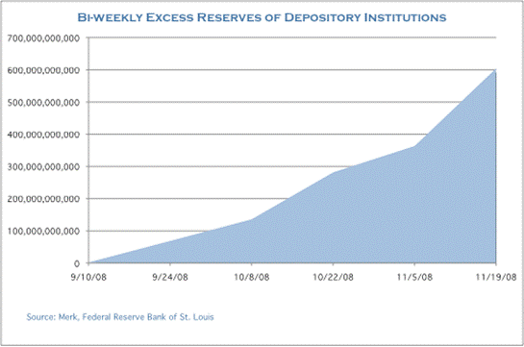
Until September, excess reserves hovered at or below about US$2 billion, but have since ballooned to over $600 billion as of November 19, 2008. Read in conjunction with our discussion above on the Fed "printing money", the Fed has thrown money at the banking system, but the banks are hoarding the cash, they 'refusing' to lend [[often, not even to each other: normxxx]]. For banks to lend money, two basic conditions must be bet: they must themselves feel strong enough to provide the credit, and they must feel that their customers— be they consumers or businesses or even other banks— are sufficiently creditworthy.
Before we discuss the next step the Fed has taken in its [seemingly frantic effforts] to unlock credit [[ie, lending activity: normxxx]] in the economy, let's pause for a second to look at a potential unintended consequence. If you are a bank and don't want to lend to the private sector, but are awash in cash, what do you do? You can deposit the cash at the Fed and earn 1% interest; you can buy Treasury bills and earn approximately zero; or you can lend money to— the government. In our view, it seems a logical conclusion for banks to buy longer dated Treasury bonds.
Banks are [normally] in the business of borrowing short and lending long. Typically, banks have deposits (short-term loans from depositors or others such sources, eg, the 'commercial paper market', callable at any time) and [use that money] to lend to finance [other than Federal government] long-term projects. This may well be the greatest carry trade of all times, except that it has neither credit, nor currency risk; it does have interest risk, i.e. if long-term interest rates go up because the market prices in the risk of inflation, then the banks could lose money.
While Congress may be furious that banks are not lending, the Fed does have a conflicting interest in keeping the long-term cost of borrowing low. Under normal circumstances, the cost of borrowing should go up as unprecedented amounts of dollars need to be raised by the Federal government (eg, the Fed itself or the Treasury) to finance the various programs in the pipeline and for the additional spending programs expected by Congress. The cost of borrowing has the potential of going dramatically higher if Asian buyers [cannot] increase their [absorption of] U.S. debt. Asian buyers [[mostly Chinese: normxxx]] have, in recent years, purchased the majority of debt issued by the U.S.
Now, however, there's less trade with the U.S., and Asian governments need to stimulate their [own] domestic economies. While some may try to keep their exports cheap [[by keeping the value of their currency low with respect to the dollar, by purchasing U.S. debt: normxxx]], the Chinese approach of investing about US$600 billion [directly] into their domestic economy is more efficient. And unlike the U.S. government, the Chinese are sitting on over $2 trillion in foreign currency reserves [[about half of it in potentially toxic US dollars which they'd be only too happy to unload for something likely to prove more stable: normxxx]] and can afford to have a massive domestic stimulus package [[largely at the expense of the US dollar and US interest rates: normxxx]]. In our view, foreign governments are unlikely to be able to step in and keep U.S. borrowing costs low.
Never underestimate the Fed. If the money thrown at the banking system doesn't stick, i.e. doesn't result in easier credit for the rest of the economy, they can also be more targeted. As of November 25, 2008, the Fed has announced it will buy mortgage-backed securities in the open market to get the cost of borrowing down. Specifically, debt securities issued by Fannie and Freddie, the government sponsored entities, will be purchased.
Almost immediately after the announcement, the prices of these securities rose, causing the yields to go down. The goal of the Fed in this program is to keep the cost of borrowing for homebuyers low. While this will keep the cost of borrowing low for those who qualify for a loan, this program may do little to provide access to the mortgage market for those that have been shunned [by] it. This includes the difficulty for many of refinancing their home when its value is less than the value of the mortgage.
In our assessment, the Fed will do anything to keep the cost of borrowing low. This has included targeted purchases of mortgage-backed securities to help homeowners; this has included purchases of commercial paper to help corporate America; it has included providing banks with massive liquidity. And it may [eventually] include the outright purchase of government debt to help finance the spending programs in the pipeline.
What happens if the Fed keeps the cost of borrowing artificially low, either directly or indirectly? Traditionally, the Fed only controls the cost of short-term borrowing, but recent Fed actions set the stage for more active involvement throughout the yield curve, i.e. also for longer dated government bonds. Think about it from the vantage point of the potential buyer of Treasury bonds or Fannie and Freddie paper.
If the yield offered is artificially low, then potential buyers are likely to abstain. After all, there may be other investments whose price are less, or not at all, manipulated. Investors don't require a high, but a fair return on their money; they want to be compensated for the risk they are taking. This includes those who lend to governments.
In a world where the cost of borrowing is artificially lowered, it may be up to the Fed to be the backstop of all economic activity as other potential buyers become reluctant to act. [[In a deflationary world, stuffing excess cash into your mattress would do fine! : normxxx]]Paradoxically, it's precisely government debt that investors are looking for because of all the uncertainty in the private sector. However, as the U.S. does not live in a vacuum, international flows of funds do need to be considered.
A foreign investor may think twice before buying U.S. government bonds or agency paper, if they are not fairly compensated for the risk they are taking. Aside from our argument above that Asian buyers may not be able to finance U.S. spending, they may be put off by unattractive yields. After all, the massive stimulus under way should [eventually prove] highly inflationary.
But if the Fed succumbs to preventing the markets from pricing potential inflation into bond prices, there has to be a valve. This valve, in our view, will be the U.S. dollar. We cannot see the dollar hold up in face of the types of intervention that are under way and that we see play out. Incidentally, a substantially weaker dollar may be exactly what Fed Chairman Bernanke wants. He has repeatedly praised Roosevelt for going off the gold standard during the Great Depression to allow the [general] price levels to adjust to their pre-1929 levels [[ie, to combat deflation: normxxx]].
This is Fed-speak for praising the pursuit of inflationary policies. Bernanke's only criticism was that FDR didn't act fast enough. Similarly, Bernanke's criticism of the Japanese encounter with deflation has been that the Japanese have not acted forceful and fast enough to fight it. What he may [have overlooked] is that the Japanese have traditionally financed their deficits [and debt] domestically.
In the U.S., these days, most of the deficit [and debt] is financed abroad. The U.S. is lucky in that at least the debt is U.S. dollar denominated so that we can, at any time, repay the debt simply by printing more money. However, the value that foreigners may place on the U.S. dollar [[eg, in their own currency: normxxx]] may be substantially less, the more inflationary the policies that the U.S. is pursuing.
Many still believe in the infallibility of the Fed. Foremost, many support the massive liquidity push because they are firmly convinced that the Fed will mop up the excess liquidity when markets normalize. Indeed, without this confidence, the markets might [have already] overwhelmed the Fed and caused a disorderly outcome for inflation and/or the dollar.
Even we don't doubt that the Fed has the best of intentions. The Fed believes that the end justifies the means. However, we doubt the end will be as intended, thus doubly questioning the means. But just as the past 22 months have shown that the markets do not act exactly as Fed officials have anticipated, we cannot see that the Fed, Treasury and other government programs will work as designed.
While we don't rule out that an inflationary boom is possible, once the liquidity is starting to be mopped up, we are afraid, economic growth is likely to collapse once again. Unless real wages can be improved, consumers must de-leverage. Propping up a broken system will simply make the later crash even more severe.
[ Normxxx Here: In other words, Axel forsees the same possibility of a general deflation interrupted by occasional bursts of runaway inflation, until we are all destitute, that I have written about earlier. ]
Similarly, if Asian governments continue to support the dollar, they will seriously weaken their own economies. In a best-case scenario, we will then face the same challenges again in 10 to 15 years, but by then a country like China won't have $2 trillion in reserves, and have far greater difficulty in stabilizing its economy [[if it survives so long with an economy on the fritz: normxxx]]. The U.S. has taken the attitude that other countries must support the dollar because it is in their interest to do so. But there's a limit to what other countries can do; there's also a limit when it ceases to be in their own interests.
In particular, it is irresponsible for the U.S. to pursue a policy that is destructive to the dollar while counting on Asian governments to prop it up. In the meantime, responsible savers in the U.S. have their savings put at risk due to all the bailouts. A substantially weaker dollar may cause price levels to rise; as a result, the value of the dollar in international markets may be a better indicator of inflationary pressures to come than the yield curve that is distorted because of the various Fed programs. Fed Chairman Bernanke may want a weak dollar and inflation, but may ultimately be getting more than he is bargaining for.
We manage the Merk Hard and Asian Currency Funds, no-load mutual funds seeking to protect against a decline in the dollar by investing in baskets of hard and Asian currencies, respectively. To learn more about the Funds, or to subscribe to our free newsletter, please visit our site
Posted by normxxx at 12:11 PM

0 comments:

