Gold Versus Silver And Wall Street Follies 1860-1900
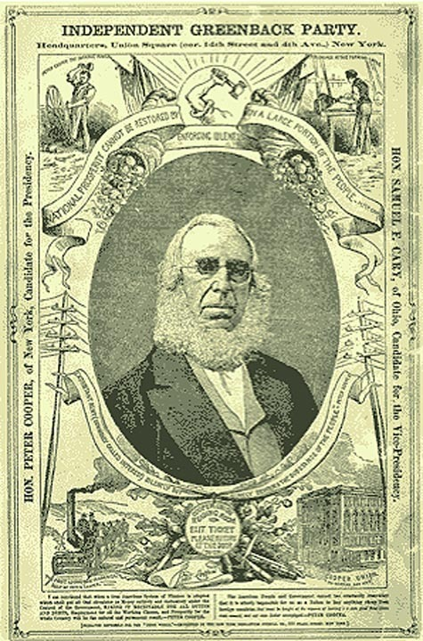
Greenback party President poster
April 2, 2008
Elaine Meinel Supkis
Time to go backwards to the Civil War. The raging debate over 'what is money' really took off at that point. Usually, wars are the cause of great financial stresses and changes. The US is at war today and our attempt at ruling the entire planet while allowing a host of Daddy Warbucks raid the Treasury is leading us into severe financial problems. The 'fix' so far is barely any different from past wars and past fixes. The main theme here is the steady erosion of local power, then Federal power as the 'cures' for war mismanagement and misspending means bankers and speculators get the upper hand, more and more. At this point in time, the government seems ready to surrender ALL of its sovereignty to bankers who have nothing but malice towards this great nation.
We will start off with the elections during the middle of the 19th Century. The Republican Party was spanking, brand new. The Democratic Party had been around for 50 years. The main fissure between the two parties was the obvious one: slavery. But there were others. The Northern parts of the nation were dominated by gold advocates. The South and West wanted silver to be the basis of wealth. But not all of the south. New Orleans leaned towards gold due to international trade just as New York and Boston.
The Greenback Party
One of the leading public issues of the immediate postwar period was related to the nation’s currency.
The heart of the debate centered on an action the government had taken to fund the Union effort in the Civil War. Between 1862 and 1865, the government printing presses issued $450 million in greenbacks, paper notes that were not backed by reserves of specie.
Simply stated, the agrarian and debtor interests wanted to keep the greenbacks in circulation and even urged that more be printed. Such a move would likely generate inflation, which was regarded as a favorable event since it would be easier to pay of debts with “cheap” money. From the political side, this point of view was adopted by many Democrats who floated a scheme to redeem war bonds in greenbacks.
The Republicans, as the representatives of the wealthy creditor interests, wanted the greenbacks removed from circulation and the return to a gold-backed currency. This would halt inflation and assure that they would be repaid in hard money.
Tensions were heightened during the depression that followed the Panic of 1873. Farmers and debtors bore the brunt of the economic distress and issued calls for the printing of additional greenbacks and the unlimited coinage of silver. These calls for action were transformed into a political movement and, in 1876, into a political party. The National Greenback Party took up the greenback refrain and pledged to fight the Specie Resumption Act (1875), as well. Peter Cooper received the group’s presidential nomination, but polled only about 80,000 votes.
ALL wars spawn depressions as they wind down. Currencies are usually devalued greatly during wars as desperate governments print money like crazy. This is the easiest way to pay for wars. All wars are expensive. By far, the most destructive war the US ever fought was with itself! The destruction of infrastructure, farming and populations was worse than anything going on in Europe before that time. The Europeans were impressed by the sheer savagery of the Civil War. But then, the Four Horsemen rode roughshod over Europe not too much later! And rode over and over again, each cycle more destructive than the previous visitation.
Farmers and debtors love inflation...at the beginning. To have additional dollars floating around, to have unlimited minting of silver: money is worth less and less so people spend it more and more. The speed at which money moves increases and thus, wealth increases. But the stolid bankers who backed global trade hate this. For they get money later, rather than beforehand. They have to calculate what a shipment would be worth when ships make it to port...if they survive the dangers of voyages. Then the money has to exchange hands with other accounting systems and everyone is very suspicious and have to be treated with care. Debasing a currency all the time means disaster. We see this in the news today!
More and more nations and businesses are now dropping the use of the dollar in their calculations for contracts in the future. Since they can't trust the relative value of the dollar and they see the US mishandling the currency, trust vanishes. Inflation is now global and the culprits are obvious: the US with its wild misspending on wars and trade and Japan with its ludicrous sub-1% interest rates, giving out loans nearly non-stop until this last 6 months. As the US wails for more 'liquidity' the rest of the world must sop up past liquidity that is a flood of debased dollars.
But we know that! Back in 1868, people could be forgiven if they thought that silver coins and easy greenbacks would equal wealth, development and contentment. They wanted to keep up the tradition of local banks issuing their own script. This, of course, leads to total chaos. It is much too close to barter to work in anything but a very local economy. Once upon a time, back when we had great inflation and little money to lend as Volker tried to clamp down on money production to save the currency, these sorts of consortiums were formed. One that I tried was a 'babysitting dollars' scheme. The game was, you babysat for 'x' hours. Then traded it for 'x' hours of someone else babysitting your own children.
Only problem was, the nice mothers who accepted these IOUs were abused by lazy, cheating mothers. The cheaters NEVER were available to reciprocate! Within a year, the thing broke down. I said, at one meeting, 'If someone calls for a return of this favor and are turned down, the other party must pay CASH.' I should have said, 'In gold species.' Heh. Well, the cheaters and lazy ladies all howled with rage over that. I never did collect the IOUs in the end.
This is why an outside 'currency' is needed. Something that doesn't hinge on someone's honesty. Only this cannot work if the central authority is not honest. As we see today. It pays to look at very old newspaper articles about all this. We start here with the 1863 financial crisis. The Union wasn't doing very well. The loans and taxes to pay for the war were now a growing problem. More money had to be raised as well as more troops. The 'open door' policy for immigration was the answer for more troops. But getting more money in international financial markets was a whole different kettle of fish.
January 31, 1863
THE NATIONAL BANKING SCHEME
The Instant Relief it will Afford to the Treasury Its Effect Upon the Currency Views of Jefferson.
In my letter of yesterday it was endeavored to be shown that success in crushing the rebellion and maintaining the Union, is much more a financial than a military question.
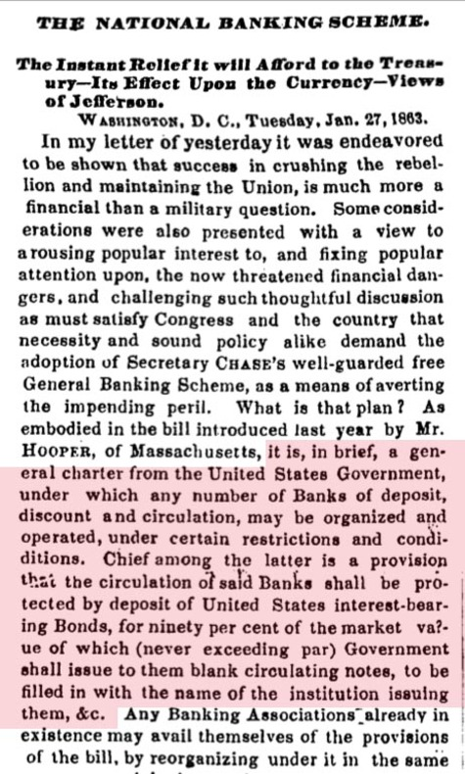
I blocked in red the important part here. We get a dim view of the future Federal Reserve in this system of funding. The banking superstructure would be PROTECTED by US Treasury bonds. At 90% market value. These early 'greenbacks' were legal documents. I possess some of these and they have a lot of legalese on the front assuring people that these were bonds, not stand-ins for money. They were supposed to be protected from inflation by interest rates set by the Treasury. Only, as usual in wartime, the rates set were below the rate of debasement of the bonds due to excess bonds being issued and then passed, hand to hand, faster and faster. And as usual, speculators lit into this and began to run exchanges that dealt with the value differential changes.
March 4, 1863
IMPORTANT FROM WASHINGTON
The Closing Hours of Congress. Great Crowds of Spectators at the Capitol. Passage of the Anti-Mediation Resolutions Through Both Houses. Reorganization of the Judiciary of the District of Columbia. The Revenue Bill and Other Important Measures. THE WORK OF CONGRESS. SPECTATORS AT THE CAPITOL. THE ANTI-MEDIATION RESOLUTIONS. THE JUDICIARY OF THE DISTRICT. THE GOVERNMENT FINANCES. THE NEW BANKING LAW. THE REVENUE BILL. THE TERRITORY OF IDAHOE. THE PACIFIC RAILROAD. THE WAR COMMITTEE. LINE OFFICERS IN THE NAVY. THE KENTUCKY COPPERHEAD CONVENTION. DESIGNS FOR CURRENCY NOTES. A BRANCH MINT IN NEVADA. ANOTHER SUPREME COURT JUDGE. NOT ENTITLED TO SEATS. NAVAL. SYMPATHY FROM THE ENGLISH OPERATIVES. REVENUE DECISIONS. CHARGE FROM HAYTI. ABSENT.
The war, as all wars, forced the Federal Government to seek new ways of finance. If we look at the history of banks in all nations, the proximity of wars to sudden bank changes is quite obvious. The American Revolutionwas triggered by sudden changes in London's banking and finance laws after the needs of the wars with France forced the Privy Purse to seek new revenues. The American people didn't just up and decide to revolt, after all. They revolted due to financial revenue changes that harmed commerce in the Americas.
Here is an old-fashioned letter to the editor: long, rather vindictive in places which makes the writer sound like some of us 'irresponsible' bloggers. In it, the writer chastises the Treasury for issuing bonds that outbid the Treasury's own previous bonds. Then the writer notes inflation followed on the heels of all this. In the end, he asks for 'one currency' rather than bills issued by various banks.
July 21, 1864
THE CURRENCY QUESTION
How to Provide for the Financial Wants of of the Government. To the Hon. Secretary of the Treasury:
SIR: Called to the high and important dignity of Chief of Finance, fearful in its responsibility, with a depleted treasury, in the midst of a sanguinary civil war, the Government in want of funds, things generally out of joint, the land covered all over with enemies, the money centres filled with financial traitors, cunning artifice and fraud resorted to by the enemy, yet fear not, be of good cheer, the people are with you
I am very amused that he called the people placing bets in this degenerating market, 'traitors.' But then, in the Civil War, the entire point was all about 'treason'. All sides were certain they were honoring their ancestors and the concept of the Revolutionaries who founded the nation. Not everyone was pleased or happy with the state of affairs. Not everyone was pro-war. And dissent centered around financial and currency issues.
"Public Sentiment Is Everything":
The Union's Public Communications Strategy and the Bogus Proclamation of 1864
Menahem Blondheim Click on image to enlarge.
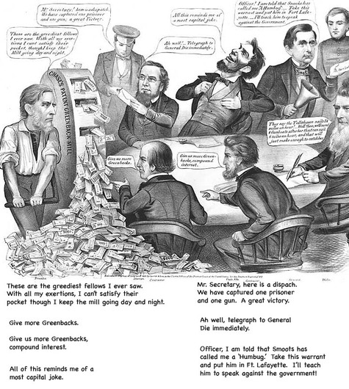
I wrote down what the characters here are saying down at the bottom. Like today, many people in power wish to crush dissent. And of course, the lack of real victories has been an ongoing problem in our ongoing wars. Every few months, our leaders proclaim 'Victory at last' only to see it vanish in a puff of smoke. The Mill water wheel here that produces wealth is very ancient. It goes back thousands of years. The ancient Norse tell us about how the Frost Giant's daughters could mill gold this way. They were kidnapped and taken to sea. The raiders ordered them to mill gold. So they did. They churned out gold day and night. But this angered them so they changed their song suddenly and began to mill salt. The ship sank and the mill fell to the bottom of the sea and this is why the sea is salty.
The concept that turning the mill too much will destroy oneself is obvious and ancient. Yet, in time of war or other distresses, banks and governments do this without batting an eyelash. The only trick that can save the mill hands turning out this debased money is to win the war and then survive the following depression. In 1873, the banking and economic system of the US collapsed due to war inflation, currency debasement and then the cessation of government spending on war. Unemployed or injured soldiers walked the streets. Immediately, wars against the native tribes to the West took off. The need to ruthlessly push the natives out was imperative. This imperialist solution meant a loss of power in the East due to political demands out West for easy loans to develop the lands wrest from the Indians. By 1875, the big banking houses in the East were demanding the government control the currency and make it 1:1 with the value of gold. This began the huge battle between gold and silver backers.
1875 Resumption Act
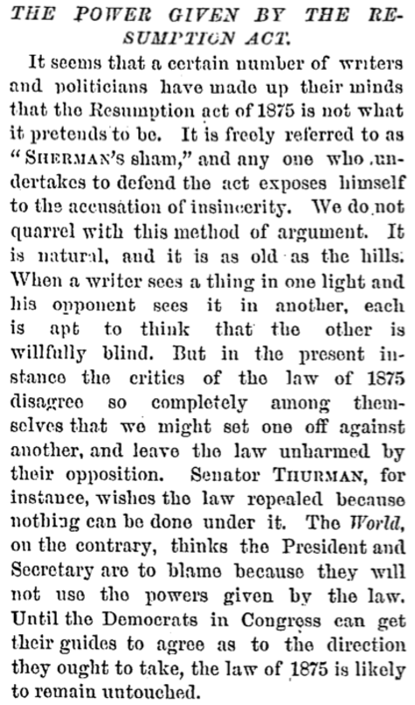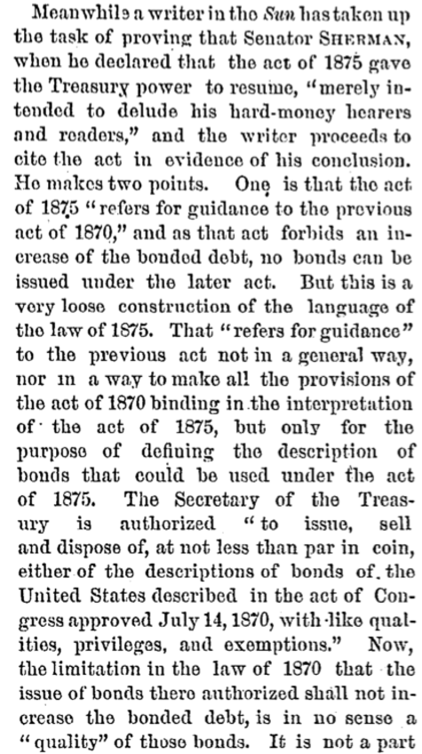
Note how the issue of circulating money and bonds intertwined. Today, people struggle to understand that money isn't just the dollar bills we sometimes [though less and less!] use. Money is based on IOUs as our dollars now point out. The pre-Federal Reserve paper money was a stand-in for coins, not free standing like they are today. Here is the exact law passed in 1969 concerning discharging government debt using paper money/bonds:
Act To Strengthen The Public Credit– March 18, 1869
Be it enacted . . ., That in order to remove any doubt as to the purpose of the government to discharge all just obligations to the public creditors, and to settle conflicting questions and interpretations of the laws by virtue of which such obligations have been contracted, it is hereby provided and declared that the faith of the United States is solemnly pledged to the payment in coin or its equivalent of all the obligations of the United States not bearing interest, known as United States notes, and of all the interest-bearing obligations of the United States, except in cases where the law authorizing the issue of any such obligation has expressly provided that the same may be paid in lawful money or other currency than gold and silver. But none of said interest bearing obligations not already due shall be redeemed or paid before maturity unless at such time United States notes shall be convertible into coin at the option of the holder, or unless at such time bonds of the United States bearing a lower rate of interest than the bonds to be redeemed can be sold at par in coin. And the United States also solemnly pledges its faith to make provision at the earliest practicable period for the redemption of the United States notes in coin.
Here is a newspaper story from 1875. The debate over the issue of how to handle the Civil War debts, how to value 'greenbacks' and such were of greatest interest. Note here how people came in by foot or horseback to hear a debate on this issue. And not some 'sound bite' debate, either. These debates took hours to hash out things and were often very rowdy including fisticuffs in the balconies. I am also delighted to say, the debaters took out their history books and cited many historical references! Over the course of my life, I have noted a decline in the ability to debate. We are now at this hideous pass whereby moderators in the media ask candidate some of the stupidest and most meaningless questions. And then play 'Got'cha'. They look for tiny errors [except with Bush who can't even string five words together].
Instead of higher and higher debates, the debates are debased. I would suggest, by the same degree as our greenbacks have been debased ever since we surrendered them to the Federal Reserve: 90% loss.
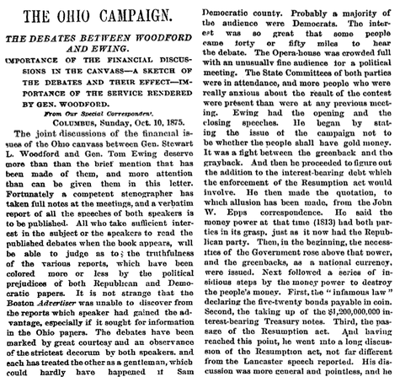
I am including this story from 1879 because it shows how our ancestors used to consumer financial news. The 'boring' stuff most people ignore today was of great interest to them, for example. Click on the story to enlarge.
August 4, 1876
RESULTS OF THE RESUMPTION ACT
THE NEW BANK CIRCULATION, BANK NOTES RETIRED, THE LEGAL TENDERS DEPOSITED TO REDEEM BANK NOTES, &C.,SHOWN BY STATES. The following official tables were prepared in the office of Controller Knox. They are interesting and important, showing in a concise form the results upon the paper currency, both legal tenders and bank notes, of the operations of the Resumption act, and the law organizing the Redemption Bureau.
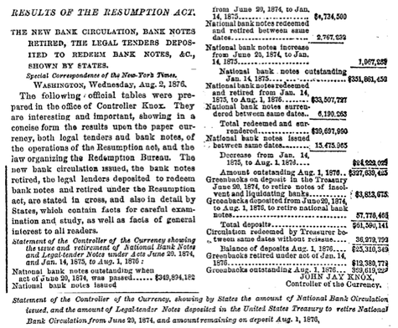
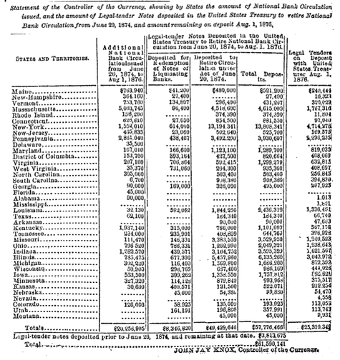
Greenbacks outstanding were $369,619,228. Over $300 million. We are spending over $12 billion a month, occupying a mostly disarmed Iraq! One US war jet can cost over $300 million. Patriots were expected to die in battle in the past and their families got little in compensation. Today, they get over half a million dollars each and every day, someone dies in Iraq. Over 4,000 so far. $2.5 billion has been spent on death bonuses so far. The worst death tolls in war for the US came from the Civil War. The government would have gone bankrupt if it paid out like the present is paying out. Back to the Resumption Act: the greenbacks were to be 'retired.' Cease circulating. America was, as is usual after a war, in a depression. This depressed prices even further. But then, all of Europe was crashing already and this depression was global.
How Resumption Works
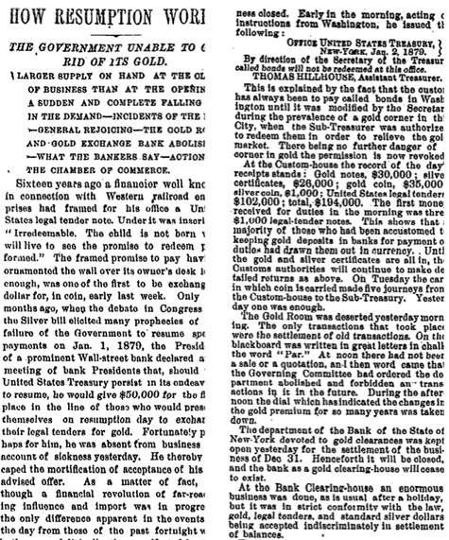
Note here that the reporters are mocking people who want gold instead of the gold certificates. Gold is heavy! Awkward to use! It can fall onto the floor and makes pockets bulge! Paper is easier. And this is true: paper trumps coins in nearly all uses. Even better are computer digits. They take up no room and can add zeros much faster than any form of money! This didn't end the debate, of course. The worry about inflation killing the value of any savings continued as it always continues.
Here is a Nast cartoon in Harper's Weekly from this time period:
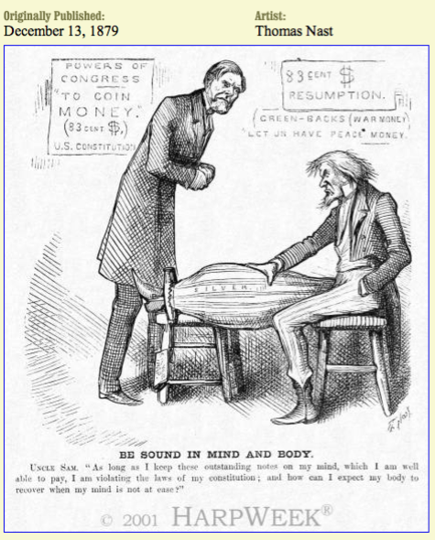
Uncle Sam. "As long as I keep these outstanding notes on my mind, which I am well able to pay, I am violating the laws of my constitution; and how can I expect my body to recover when my mind is not at ease?"
The “money question” was one of the major issues of American politics in the last three decades of the nineteenth century. Both parties divided on whether the nation’s money should be “hard money”—gold coins—or “soft money”—paper currency called “greenbacks” that were unredeemable in gold, or an unlimited supply of silver coins (“free silver”). In January 1875, Congress passed the Specie Resumption Act, declaring that the nation would return to the gold standard in January 1879. The advocates of an inflationary currency were unsuccessful in their efforts to overturn the Specie Resumption Act, but they did manage to enact legislation reintroducing silver coins in 1878.
Cartoonist Thomas Nast, a hard-money backer of the gold standard, criticizes the silver supporters by depicting Uncle Sam’s leg swelling (inflating) from being caught in the silver trap. The national symbol argues that the silver trap is bad for his constitution, a literal reference to his physical well being which the artist uses to imply that silver coinage is contrary to the U.S. Constitution. In the background are signs attesting to silver coins being worth only 83 cents to the gold dollar. Standing over Uncle Sam is a concerned John Sherman, the federal treasury secretary and an important figure in late-nineteenth century finance and politics in general.
And yet another Harper's Weekly cartoon:
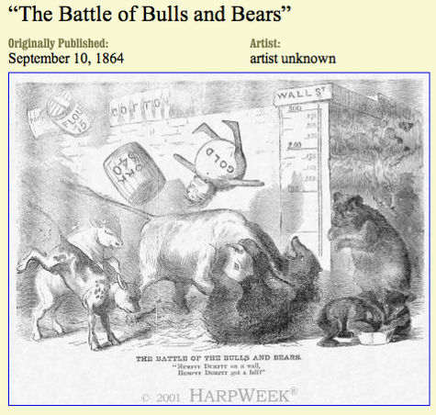

Overall, the Northern economy was stimulated by the Civil War, and great wealth was accumulated through the stock marketand other investments. Yet, the profitability of stocks and gold fluctuated widely since they were closely related to the ups and downs of results on the battlefield. This cartoon reveals one of the periodic downturns in the volatile market, where gold, pork, flour, and other items plummet, while the bears and bulls fight each other on Wall Street.
To finance the extraordinarily expensive Union war effort, Treasury Secretary Salmon P. Chase and Congress borrowed millions of dollars from a consortium of private American banks, reorganized the banking system, imposed a new set of internal taxes, printed paper currency ("greenbacks") not backed by gold, and issued government bonds. These policies increased the self-interest of the financial community in the success of the Union cause, enhanced its influence in government affairs, and inaugurated a wartime economic boom.
Those with money to invest looked to Wall Street, where margin buying (sometimes as low as 3% of a stock's cash value) helped fuel a roaring bull market. In January 1862, the New York Tribune reported on the great excitement among investors, "The intense desire to buy almost any kind of securities amounted almost to insanity. ... The oldest members of the Board cannot remember such a day of rampant speculation." By the next year, stockbrokers were earning unprecedented commissions of $3000 weekly.
Perhaps most controversial of all was gold trading. Union losses undercut confidence in the federal government and thus decreased the value of the government-printed greenbacks. The decline of greenbacks, though, meant people turned to gold, forcing its value to elevate. Gold investors, therefore, had a stake in Confederate victories and were known to sing "Dixie" when such news reached the floor of the New York Stock Exchange. In reaction, the Exchange banned gold trading, but gold brokers simply moved to other premises, soon establishing the Gold Exchange. In 1864, the price of gold reached an all-time high, compelling Secretary Chase to sell $11 million of the government's surplus gold in mid-April. The price of gold dropped temporarily, but quickly rebounded.
Despite the overall upward trend, the market fell when the Union suffered losses, and rose when it triumphed. At the time this post-dated cartoon hit the newsstands on September 1, progress of the Union military throughout the summer of 1864 had stagnated, thus producing a dip in the market. The message conveyed by the cartoon, though, is more ambiguous. The toppling of gold, the question in the caption, and the uncertain outcome of the bears and bulls battle seem to indicate that the Union victory in August at Mobile Bay had an adverse affect on gold, but was not enough to improve the other markets. Later in September, however, the fall of Atlanta to the Union and victories in the Shenandoah Valley of Virginia revived the stock market, as well as the Union cause and President Lincoln's reelection hopes.
Gold shot up to $1024 an ounce and then very suddenly, collapsed all the way back down to the high $800s this last week. But it will edge back upwards. For the same reasons we see in this 130 year old story. Our forefathers and foremothers debated each other with history books in hand. Today, we see debates conducted by people who seem to have Alzheimers. Gold tonight is back up to $900 an ounce. Since inflation has been made worse, not better, the chances of it climbing is pretty high. Oil is staying pretty much over $100 a barrel. The hopes of the financiers and government agents at the beginning of the week seems to be flagging. I cannot see inflation dying if they are trying even harder to create 'liquidity'. Liquidity is inflation! And inflation can move into Wall Street stocks just as it did so swiftly in the Civil War, WWI and other wars. But as we lose the Iraq war, lose the 'War on Terror' and as we irritate Russia and China, both of whom can bankrupt us, the joy on Wall Street won't last too many years. The woeful condition of US finances is obvious. We get much less bang for our bucks today. And we can't turn on the Indians and steal their lands to make up for our failed wars!
We can't rebuild America by taking over much of the continent. We can't go on gold hunts or expand our farming base. We have limits. And the limit is NOT the sky.
Email this post
Culture of Life News Main Page

Choose a language to translate this page!
April 02, 2008 | Permalink

TrackBack
TrackBack URL for this entry:
http://www.typepad.com/t/trackback/763647/27711662
Listed below are links to weblogs that reference Gold Versus Silver And Wall Street Follies 1860-1900:

Comments
Check it out, Greenspan may not have earned his PhD from NYU after all:
http://online.barrons.com/article/SB120675340444773623.html?mod=b_hpp_9_0002_b_this_weeks_magazine_home_right
Big surprise!
Posted by: AF | April 02, 2008 at 11:03 PM
What? He got it from the University of Phoenix? HAHAHA. Or maybe he got it from the Weimar School of Economics?
Posted by: Elaine Meinel Supkis | April 02, 2008 at 11:51 PM
The main fissure between the two parties was the obvious one: slavery.
Lets set this one right. Slavery was a political football at the time. Wasnt their a Tarrif that actually instigated this war. Was it not about cotten?
Posted by: Dutch | April 03, 2008 at 12:11 AM
@Dutch:
They were both issues. Slavery was a visceral issue to many citizens/voters. The tariff issue was not so visceral to voters but was to exporters. To paint with a very broad brush, the south was basically an agricultural exporting section ( king cotton ) and needed low tariffs. The North was beginning to industrialize and thought it needed high tariffs to protect the infant industries from low cost imports from England. High tariffs would have bankrupted the south's agrigultural base.
( And put a lot of slaves into the same status as idle machinery, only slaves still have to be fed, and housed unless one wants to contemplate less decent alternatives.)
The election of Lincoln, a railroad lobbyist lawyer strongly backed by the high tariff northern banks, railroads and baby industries, as well as the anti-slavery northern voters led to the rift.
Now look at a map.
Notice the very long and very porous land borders that would have demarcated two separate nations. The Northern interests knew that allowing the South to go peacefully would have rendered any high tariff moot. The tariffed goods would have flowed to Confederate ports and then wended their way North through the various backwoods trails and roads. ( Think Moonshining on a HUGE scale ). In effect, if the North had led the south go its own way, the southern ports would have boomed as industrial imports destined for northern use would have moved to friendly low tariff south and then slid northwards. Not only that but the south would have faced an increasing demand for its cotton and would have led to increased westward expansion of the southern agricultural interests.
There was and is nothing in the constitution to prevent any state or group of states from leaving the voluntary Federal compact. So Lincoln was elected, South Carolina seceeded, other states seceeded, Lincoln was inaugerated, things became tenser and tenser, Lincoln forced the issue by sending Northern Military units ( a naval resupply group and warships ) into foreign territory ( The Confederacy, specifically Fort Sumpter) in an act of aggression against a new republic. The Confederacy defended itself as any sovereign nation would.
The War of Northern Aggression was the fourth war fought over money by the US. ( 5th if one counts the revolution against England ).
Slavery only became a hot button issue during the war, when the Lincoln Administration thought it was losing. Then the issue became the inhumanity of slavery not the needs of the northern banks and railroads and industries to have high protective tariffs. There was slavery in the north before and during the war, the emancipation proclamation only applied to slaves in the areas of the continent NOT under the control of the Northern armies.
Slaves in Maryland, NY, PA, Delaware, NJ, Mass, etc. were not set free by this proclamation.
Posted by: CK | April 03, 2008 at 08:30 AM
Wrong, CK , on one very very important item:
The Supreme Court ruled that Southern Slave States could go NORTH and even if the NORTHERN states had laws freeing slaves who left southern states, the FEDERAL GOVERNMENT had to LET THE SLAVERS COME NORTH TO RETRIEVE THE SLAVES!!!
This was a HUGE instigation for the war! This made it illegal to harbor fleeing slaves EVEN IN THE NORTH. The fury this caused in the north was huge!
Even so, nothing happened, they voted for the new Republican party and when Lincoln came into office, IMMEDIATELY, the slave states ATTACKED THE FEDERAL GOVERNMENT. Fort Sumpter.
Not one law was passed concerning slavery when this happened. The tariffs issue was a side issue. It didn't lead to shooting. But the ANTICIPATION of laws protecting RUN AWAY SLAVES was the cause of the southern premptive strike.
Posted by: Elaine Meinel Supkis | April 03, 2008 at 09:42 AM
Hello Elaine,
I found s.th. interesting about the devaluation of money from 1846, taken (I can not scan it so I type it out) from page 127 from the book "Whatever Happened to Penny Candy?" by Richard Maybury:
Sign posted in Trade Store at Sutter's Fort State Historic Park
Notice
Discounting of Currency
1. All Paper Currency drawn upon State Banks and State Offices of Comptrollers will be discounted 45% Per Centum on Transactions. There will be no Exceptions.
2A. Mexican and British Bank Drafts will be discounted 27% Per Centum on Transaction.
2B. All Bank Drafts on Pacific Coast Merchants, Banks, Lending Houses, and Ships Pursuers will be discounted 33% Per Centum on all Transactions.
3. All Bank Drafts and Letters of Credit or Exchange, on European Merchants, Banks, Lending Houses or Governmental Agencies doing Business on this Coast and rdeemable in Silver or Gold will be discounted at 15% or exchanged at a 20 % Discount.
4. All Coinage will be Exchanged or Accepted at Face Value minus 5% on Volume of Business Transactions. Banking of Funds on Sandwich Island Accounts Payable - 5% of Volume.
Drafts and Warrants upon this establishment will be Accepted at Face Value for Trades - or - at 10% Discount for Exchange of Coin or Drafts of Letters of Credit.
By Order of
John A. Sutter
Proprieter
January 14, 1846 George N. Loker
Chief Clerk
Posted by: Reimund from Berlin | April 03, 2008 at 10:22 AM
HAHAHA. Good catch.
The sales clerks had to have PhDs in economics to write out sales tickets.
Basically, they haggled over prices. This long list was a warning about what was being haggled over. So people wouldn't whine. And it was to stop them from overpricing themselves. Of course, the sales price was ultimately whatever the buyer and seller agreed to. There being little competition in the Wilderness.
Guns were always useful as negotiation tools.
My family lived in the Wild West. We liked it there, frankly. 'If you can see your neighbor's chimney smoke, they are too close.' is a family saying.
Posted by: Elaine Meinel Supkis | April 03, 2008 at 01:00 PM
And put a lot of slaves into the same status as idle machinery, only slaves still have to be fed, and housed unless one wants to contemplate less decent alternatives.)
Exactly, now the overhead of taking care of slaves disappears.
Dont get me wrong, I liked Lincoln, but it really didnt matter who won the war. The monied interest profited no matter who was the victor, the failure was in the north of not getting all of Lincolns reforms pushed through. Now we all are slaves! HA!
The Supreme Court ruled that Southern Slave States could go NORTH and even if the NORTHERN states had laws freeing slaves who left southern states, the FEDERAL GOVERNMENT had to LET THE SLAVERS COME NORTH TO RETRIEVE THE SLAVES!!!
This was a HUGE instigation for the war! This made it illegal to harbor fleeing slaves EVEN IN THE NORTH. The fury this caused in the north was huge!
Yes, but in that time it would be the same as harboring inmates today! They were property just as prisoners are property today, just look at our private prisons and the amount of prisioners!
Posted by: Dutch | April 03, 2008 at 03:51 PM

Post a comment

