Mike Lindell's "Absolute Proof" recording, with a series of interesting people involved in the Nov 3, 2020 Election.

Mike Lindell, Mary Vanning, and Brannon Howse Present the Docu-movie:
Absolute Proof
Exposing Election Fraud and the Theft of America
by Enemies Foreign and Domestic

Location | Rating | Concept / Term / Subject | More Information
48min54sec | R | Dr. Shiva, who ran for State Senate in Suffolk County, MA, in October 2020
54min24sec | +++ R | "Weighted Race" Feature | https://en.wikipedia.org/wiki/Weighted_voting
54min40sec | +++++ R | Diebold Manual 2002 version: "a weighted race has the same attributes as a candidacy, and other than being weighted, is counted in the same manner as candidacies."
56min15sec | ++++ R | "The Twitter Thing" Dr. Shiva was weighted 0.666 "and the other guys (candidates for senator) by 1.2". Nationally, Bob Barr was notified. Mass nor Federal did anything. | See GEMS, Fraction Magic for validation of Shiva's fractional voting example in Massachusetts. Like Lindell's in Texas! Governments in the USA do not want to admit that this could be, let alone is, happening.
1:01:40 | ₊₊₊ | "The real crime scene in America is these computer Algorithms.
1:02:04 |  | Patrick Colbeck had been a state senator. Was a Poll Challenger – Detroit /Wayne County/Michigan on 2020 Nov 03 night.
1:04:53 | +++ R | Melissa Carone, was hired for two nights by Dominion. | C:\DESKTOP, sweptFrom 1Dr 'DESKTOP'\DESKTOP - 1 PUSHEDDOWN\_Votesec - 202011 - a 'Free & Fair' Election\Michigan\Melissa Carone  http://chasegalleryconnect.org/FNC_C/DESKTOP,%20sweptFrom%201Dr%20'DESKTOP'/DESKTOP%20-%201%20PUSHEDDOWN/_Votesec%20-%20%20%20202011%20-%20a%20'Free%20&%20Fair'%20Election/Michigan/Melissa%20Carone/  Mail-in ballots could not be scanned. "The batches are only 50" "I said, this machine has a count of over 400 here. What's going on here?" "…I said, we have a huge problem here….He pulled me aside and said "I don't wanta hear that we have a problem." He is actually a part owner of Dominion.
1:08:18 |  | We're here with Matt DePerno. He knows people in Antrim County. I filed a lawsuit. The case centered on local politics. Hand recount on Nov 21 and again on Dec 17. | Lindell, it turned out, is imagining international intervention here, when in fact this Antrim County thing is now well understood to be an intra-State human error. SKIP THIS HERE.
1:16:02 |  | At this point Antrim County and Bill Bailey, a resident of Antrim County, got Russell James Ramsland, Jr. involved. DePerno filed a lawsuit in the name of Bill Bailey! | We have a better analysis of this. It was, indeed, Human (election officials) error plus bad voting software design. Corrected by Antrim Co.
1:15:59 |  | Forensic images of the Dominion System.
1:18:16 |  | What we (Ramsland's guys) found was that on Nov 4^{th,} at 11)3PM, …
1:23:07
1:25:54 |  | This, from the Dominion Manual, tells you how to connect to the internet.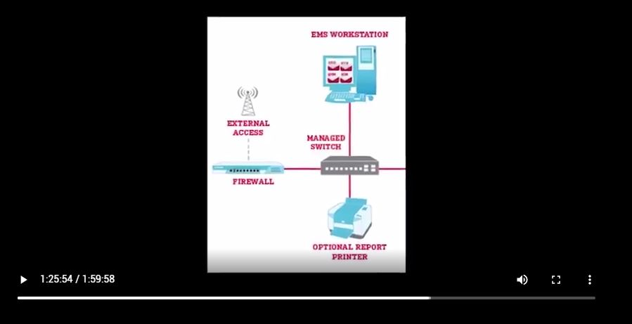
1:26:12 |  | Eric Coomer of Dominion Voting Systems
1:36:17 | +++ R | On the phone with Mary Fanning "Absolute Proof" | Over 60% of the attacks were from China. Exactly the vote totals taken from Donald Trump.
1:43:14 | +++ R | A Video "Absolute Proof" of a Trump attack mostly from China | Presented to James Comey in 2015.
1:49:46 |  | General McInary "Driven by China" "We are going against Globalists"
1:53:48 |  | Terry Turchi "Where was the FBI?" Counterintelligence Division - compromised!
1:58: |  | "Absolute Proof"
1:59:58 |  | Mike Lindell, Mary Fanning, and Brannon Howse Present the Docu-movie:  Absolute Proof  Exposing Election Fraud and the Theft of America  by Enemies Foreign and Domestic | This claim voiciferously rejects Lindell, Fanning, and any notion of a Foreign Election Attack.

https://www.sos.texas.gov/elections/laws/votingsystems.shtml
https://www.thegatewaypundit.com/2020/11/dominion-voting-machines-include-weighted-race-feature-whose-purpose-cheat-elections-contacted-dominion-not-get-response/
https://www.sos.texas.gov/elections/laws/votingsystems.shtml

