From: https://beckernews.com/here-are-the-documents-the-u-s-embassy-in-ukraine-scrubbed-on-biological-threat-reduction-labs-44315/

Here are the Documents the U.S. Embassy in Ukraine Scrubbed on ‘Biological Threat Reduction’ Labs
March 7, 2022
by Kyle Becker
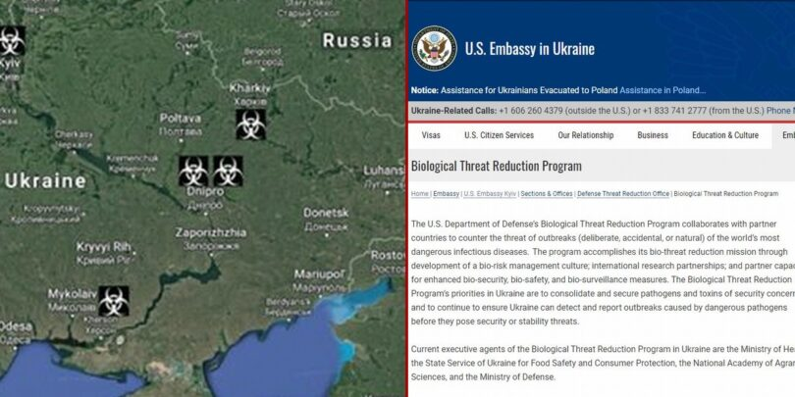

Written by Kyle Becker
Russian accusations of a U.S.-funded and administered ‘biowarfares’ laboratory research program in Ukraine has led to rampant speculation about the nature of these Pentagon-funded laboratories. The Russians’ insistence that it has evidence of such a bioweapons program has become a major hurdle at the diplomatic negotiations between Russia and Ukraine in Belarus.
Russian foreign minister Sergei Lavrov charged at a press conference last week that “the Pentagon built two biowarfare labs and they have been developing pathogens there in Kyiv and in Odessa.” Lavrov also compared the presence of the laboratories to the United States’ Weapons of Mass Destruction program allegations that led it to invade Iraq in 2003 and topple dictator Saddam Hussein.
Leonid Slutsky, head of the Duma Committee on International Affairs and a member of the Russian delegation at the talks with Ukraine, argued that the purported development of biological weapons components “confirm that the Russian Federation had good reasons for conducting a special military operation to demilitarize Ukraine.”
Major General Igor Konashenkov, an official representative of the Russian Ministry of Defense, charged on Sunday that “components of biological weapons were being developed in Ukraine, in close proximity to Russian territory.”
Amid the Russians’ accusations, the U.S. Embassy in Ukraine has scrubbed a number of documents related to the Ukrainian “Biological Threat Reduction” program.

Those documents have been retrieved and can be read below. The documents show both the locations of the Ukrainian laboratories and the Department of Defense’s listing as a “donor” to the program.
Ukraine Embassy Documents on Biological Threat Reduction Program by Kyle Becker on Scribd
“The Electronic Integrated Disease Surveillance System (EIDSS) is a software system which is designed to strengthen monitoring and prevention of human and animal diseases within the One Health concept, and facilitate compliance of International Health Regulations (IHR) 2005,” the embassy document states.
In 2011 EIDSS was introduced in Ukraine with installations at the following sites:
- Central Sanitary-Epidemiology Station in Kyiv (CSES)
- Ukrainian Research Anti-Plague Institute in Odessa (URAPI)
- Vinnitsa Oblast Sanitary-Epidemiological Station
- Vinnitsa City Sanitary- Epidemiological Station
- Kalynivska Rayon Sanitary- Epidemiological Station in Vinnitsa Oblast
- Zhitomir Oblast Sanitary- Epidemiological Station
- Khmelnitska Oblast Sanitary- Epidemiological Station as regional sites
“The main objective of the program is to implement EIDSS at the sites of the State Sanitary-Epidemiological Service of Ukraine for monitoring and outbreak prevention of diseases including those caused by Especially Dangerous Pathogens,” the document adds.
The [U.S.] Department of Defense expenditures as listed for select Ukrainian laboratories follow below:
- Dnipropetrovsk Diagnostic Laboratory (USD $1,935,557)
- Dnipropetrovsk State Regional Diagnostic Veterinary Laboratory (USD $1,810, 547)
- Kharkiv Diagnostic Laboratory (USD $1,638,375)
- Luhansk Regional Diagnostic Veterinary Laboratory (USD $1,746,312)
- Lviv Diagnostic Laboratory (USD $1,927,158)
- Lviv Regional Diagnostic Veterinary Laboratory (USD $1,734,971)
- Vinnytsia Oblast Laboratory Center (USD $1,504,840)
- Zakarpartska Oblast Laboratory Center (USD $1,920,432)
- Institute of Veterinary Medicine of the National Academy of Agrarian Sciences ( USD $2,109,375.23)
The U.S. Embassy in Ukraine explained the operation of the laboratories and accused the Russians of spreading disinformation about their nature in 2020. Watch:
Advertisements
“The biological threat reduction program is working in 27 countries,” the U.S. ambassador to Kazakhstan William Moser said. “We’ve feel this disinformation and misinformation is done just to really exploit divisions.”
“We’ve had accusations that some research projects were being used to create threats, not to identify threats and reduce them,” Dr. Mary Lancaster added. “Ulterior motives are being injected where none exist.”
“We’ve built these capabilities for the partners, their central reference labs for research,” Lance Brooks said. “They publish everything they do. They invite the international community into their laboratories. They’re working on behalf and the benefit of the people of their respective countries.”
Russian foreign minister Sergei Lavrov, however, has accused the U.S. and Ukraine of a lack of transparency.
“We have data that the Pentagon is preoccupied with the chemical and biological installations in Ukraine,” Lavrov claimed. “The Pentagon built two biowarfare labs and they have been developing pathogens there in Kyiv and in Odessa.”
“And now they are concerned that they may lose control over these labs,” he argued. “And you know what it may be like in future. And the Americans decline flatly and resolutely to start an inspection mechanism as part of the convention for the prohibition of chemical weapons. And they build new chemical and biological facilities all across Russian borders.”
“And, you know, many other developments happen,” Lavrov went on. “The CIA has been on the ground in droves, and they have been training the Ukrainian army, not to wage a war with Poland, apparently. And when developments in Iraq happened, when the United States claimed it was a threat to the U.S. national security, did anyone ask back then why the United States back then decided to bring a country 10,000 kilometers off its coast to order, because the U.S. is a great power?”
“When Russia says there is a threat to us, they start telling us that there is not a threat at all, but you know, we will decide what is needed to provide for our security,” Lavrov stated. “And it’s close and next to our borders, we will not go 10,000 kilometers away to enforce our rules.”
Russia is therefore invoking the United States’ invasion of Iraq in 2003 as a pretext for invading Ukraine. It turned out after the invasion that weapons inspectors could find scant if any evidence that then Iraqi dictator Saddam Hussein was maintaining an active Weapons of Mass Destruction (WMD) program. However, the New York Times reported that Iraq had old stockpiles of WMDs that were discovered by U.S. soldiers.
In May 2020, Lavrov accused the United States “categorically opposing the adoption of a protocol to the convention of banning biological and toxin weapons, which would establish a mechanism to verify compliance by member countries with their obligation not to produce such weapons.”
“The United States’ reluctance to ensure transparency of its military-biological activities in different regions of the world, of course, raises questions about what is really happening and what goals are being pursued,” Lavrov said at a news conference after a virtial meeting with foreign ministers of the Shanghai Cooperation Organization (SCO).
“These laboratories are densely formed along the perimeter of the borders of the Russian Federation, and, accordingly, next to the borders of the People’s Republic of China,” Lavrov added.
The U.S. Embassy in Ukraine has published information about its “Biological Threat Reduction Program” in Ukraine:
The U.S. Department of Defense’s Biological Threat Reduction Program collaborates with partner countries to counter the threat of outbreaks (deliberate, accidental, or natural) of the world’s most dangerous infectious diseases. The program accomplishes its bio-threat reduction mission through development of a bio-risk management culture; international research partnerships; and partner capacity for enhanced bio-security, bio-safety, and bio-surveillance measures. The Biological Threat Reduction Program’s priorities in Ukraine are to consolidate and secure pathogens and toxins of security concern and to continue to ensure Ukraine can detect and report outbreaks caused by dangerous pathogens before they pose security or stability threats.
Current executive agents of the Biological Threat Reduction Program in Ukraine are
- the Ministry of Health,
- the State Service of Ukraine for Food Safety and Consumer Protection,
- the National Academy of Agrarian Sciences, and
- [Oh -] the Ministry of Defense [aka the War Department].
The fact sheets on the U.S. Embassy in Ukraine website on the following laboratories are cited above.
Advertisements
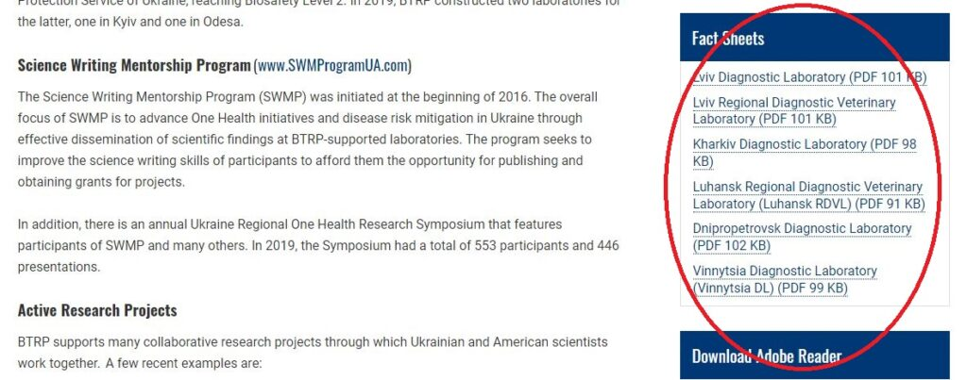
- Lviv Diagnostic Laboratory (PDF 101 KB)
- Lviv Regional Diagnostic Veterinary Laboratory (PDF 101 KB)
- Kharkiv Diagnostic Laboratory (PDF 98 KB)
- Luhansk Regional Diagnostic Veterinary Laboratory (Luhansk RDVL) (PDF 91 KB)
- Dnipropetrovsk Diagnostic Laboratory (PDF 102 KB)
- Vinnytsia Diagnostic Laboratory (Vinnytsia DL) (PDF 99 KB)
The U.S. embassy website partly corroborates a ‘viral map’ that purports to show American biological laboratories in Ukraine.
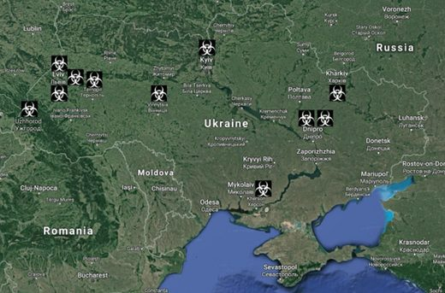
There is no strong evidence of U.S. funded “bioweapons” research in Ukraine. Therefore, there is a strong possibility that this is Russian disinformation. But the U.S. embassy in Ukraine lists biological “threat reduction” laboratories, similar to the ones the U.S. funded in Wuhan. The readers can draw their own conclusions.

