From: http://nypost.com/2016/11/06/despite-countless-scandals-huma-abedin-remains-a-mystery/

MAUREEN CALLAHAN

NEWS

Despite countless scandals, Huma Abedin remains a mystery
By Maureen Callahan
November 6, 2016 | 5:09am | Updated

For nearly 20 years, one question has been asked, over and over, about Hillary Clinton’s closest, most enigmatic aide: Who is Huma Abedin?
As the election hurtles to its inglorious end, that question has taken on new weight.
With the FBI looking into Clinton e-mails contained on a laptop shared by Abedin and estranged husband Anthony Weiner — himself now the subject of an FBI investigation for sexting with a 15-year-old girl and sending a crotch shot with his toddler son sleeping next to him — Abedin has gone from loyalist to liability.
Though she hasn’t been seen with Clinton since the story broke on Oct. 29, the campaign insists she is not going anywhere.
“Huma continues to play an invaluable role,” campaign chair John Podesta told The Post Friday. “No one is more loyal to Secretary Clinton, and she remains one of her closest advisers. We all admire her grace and fortitude.”
Still: Just who is she?
Not much is known about Abedin’s life before Clinton Inc. She was born in 1976 in Kalamazoo, Mich., to an Indian father, Syed, and a Pakistani mother, Saleha. Both were academics and devout Muslims. When Huma was 2, the family moved to Saudi Arabia, but almost nothing is known of Huma’s childhood and teen years. She returned to the United States to attend George Washington University, majoring in journalism with a minor in political science.

Her father co-founded the Journal of Muslim Minority Affairs, and after his death in 1993, her mother, whose writings subscribe to Sharia law, took over as editor-in-chief, a post she holds to this day. The journal has published articles in favor of female genital mutilation, the sexual subjugation of women and murder of apostates. Earlier this year, The Post reported that Abedin was listed as assistant editor on the masthead from 1996 to 2008; the Clinton camp said she was only a figurehead.
In 1996, still an undergrad, Abedin began interning for Hillary at the White House. It’s the only job she has ever really known, and her loyalty to Hillary was forged in the crucible of the Lewinsky scandal and Bill Clinton’s impeachment.
So much of the public fascination with Abedin has to do with her contradictions: She’s a practicing Muslim who married a Jewish man, who abstains from alcohol yet is never without her red lipstick, the daughter of a woman who believes men are wholly superior yet has devoted her life to potentially the first female president of the United States.
“She was a very, very religious person — she didn’t smoke, drink or swear, always very polite,” a Clinton insider told Newsweek earlier this year. “A lot of times, Hillary would snap her fingers and go, ‘Gum.’ And Huma would fetch it.” This same source said Abedin was so dedicated that when she heard Hillary had been forced to carry her own bag up a staircase, she almost cried.
Another insider, however, told Newsweek that Abedin’s public image is pure projection. “She wasn’t that interesting a person,” the source said. “She has been turned into a myth.”
Ever since Hillary began running for president nine years ago, Abedin has been part of her campaign strategy. In 2007, Vogue ran a fawning profile of Abedin, who sat for famed fashion photographer Norman Jean Roy. She was depicted as a reluctant star, not just Clinton’s handmaiden but something of a soul mate.
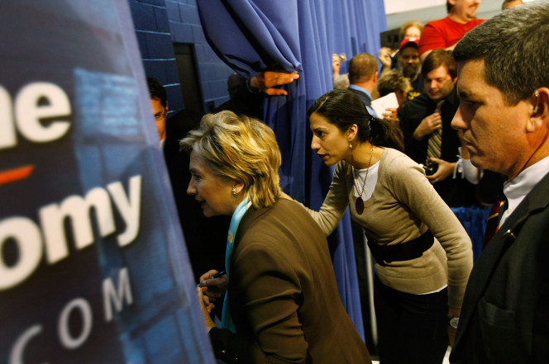Clinton and Abedin in 2008.Photo: Getty Images
“They are lucky to have found each other,” the late Oscar de la Renta told the magazine.
“I don’t know if it’s a chicken-or-the-egg thing — Hillary affecting Huma or the other way around — but together they work,” said actress and longtime Clinton friend Mary Steenburgen.
“I’m not sure Hillary could walk out the door without Huma,” said Clinton adviser Mandy Grunwald.
That year, the New York Observer asked the same question, speaking to many in Clinton’s circle. Abedin was lauded as a “mythical figure” who was perfectly put-together, whip-smart, glamorous, gracious.
“The coolest customer,” said Anthony Weiner, then just an admirer. “In fact, I think there’s some dispute as to whether Huma’s actually human or not.”
“I’d call Huma one-in-a-million,” Clinton staffer Philippe Reines said. “She is truly one of a kind, one in a billion. We are all in awe of her poise, grace, judgment, intellect and her seemingly endless energy.”
Abedin famously came to be regarded as family by the Clintons. Bill officiated at her 2010 wedding to Weiner, and at a pre-wedding celebration, Hillary called her a “second daughter.”
Modal Trigger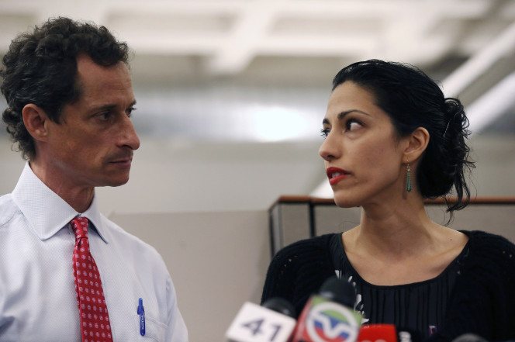Abedin with Anthony Weiner during a press conference in 2013.Photo: Getty Images
When Weiner was first caught sexting in June 2011, Abedin was a sympathetic figure: newly married, pregnant with their first child, dragged into an all-too-common DC sex scandal. She was admired for her quiet dignity, her decision to stay in the marriage, her work rehabbing Weiner’s image.
She would tell the press that Clinton, no stranger to such humiliations, was sympathetic. The couple framed it as a sex scandal without actual sex, a narrative that made sense.
One year later, The Post reported that Abedin was pushing for a public confession so that Weiner could get back into politics; she was tired of being hitched to a pariah. Weiner himself later said as much.
“She was very eager to get back into the life that I had taken from her,” he said. A run for office “was the straightest line to do it.”
In 2013, the couple did cover stories with The New York Times Magazine and People, posing with their baby son, Jordan, laying the groundwork for Weiner’s political re-entry while claiming the opposite.
The previously private Abedin was front and center. They posed for family photos in the multimillion-dollar Park Avenue South apartment loaned to them by a Clinton donor. Abedin didn’t speak of this, or of the three additional paychecks she was pulling down through Clinton-related entities while working at the State Department. Like a good wronged political wife, she simply testified to her husband’s decency, the unfairness of their lives wrecked by “one fateful tweet.”
“I want people to know we’re a normal family,” Abedin said.
“I’m very happy in my present life,” Weiner told People, and offered a perfectly canned pull quote: “The only next dramatic steps I’m planning on are Jordan’s first.”
They talked about the intense therapy Weiner had undergone — therapy he later admitted was a lie. Upon Weiner announcing his 2013 run for mayor of New York City, the couple allowed a camera crew to follow them through the campaign.
Of course, that imploded in yet another sexting scandal, and the resulting documentary, this year’s “Weiner,” was most shocking for its depiction of Huma Abedin as a political animal, bloodless in her ambition.
Was this, in fact, the real Huma?
Abedin leaving Hillary Clinton’s plane in Ohio.Photo: Getty Images
In an attempt to salvage her husband’s campaign, Abedin stood next to him at a hastily called press conference and defended him, yet again. She allowed Weiner to use their son as an Election Day prop, the child hysterical when faced with flashbulbs. She was filmed scolding a top campaign staffer, in tears over this latest betrayal, warning her of the press outside.
“Just a quick optics thing,” Abedin said. “I assume there’s photographers still outside — so you will look happy?”
As the staffer blanched, Abedin quickly self-corrected.
“I’m saying this for you,” Abedin said.
Curiously unreported in the documentary was the 2011 investigation into Weiner’s sexts with a 17-year-old girl, something the Clinton campaign was aware of: The recent WikiLeaks dump includes a June 10, 2011, e-mail exchange among Podesta and Clinton aides Jennifer Palmieri and Neera Tanden.
“Oof,” Palmieri wrote, including a link to the Fox News story.
It’s fair to assume that Abedin knew back then her husband was, at the very least, improperly communicating with a minor. She finally left him this past August, hours after the news about the sext involving their son broke. She claimed they had been secretly separated for months, yet at the time they were still living together in the Park Avenue South apartment.
Whatever the truth, she couldn’t have stayed in the marriage and remained at Clinton’s side.
This isn’t to say that Abedin’s motives in finally leaving were purely political. She is, after all, the daughter of a fundamentalist Islamic woman who believes that women have no rights, are not equal to men and should abide their husbands, no matter what abuse or humiliations they may suffer. The other “mother” in her life, the one with whom she has spent nearly every day since the age of 19, has modeled the ambitious political marriage, the calculus of short-term suffering, the ritual degradations of a husband’s sex scandals in exchange for power.
How has Abedin reconciled such conflicting beliefs? Maybe she hasn’t. Maybe in both role models she has come to internalize the inevitability of a husband’s betrayal, and quite possibly believes she deserves it. It would, in many ways, explain Abedin’s inscrutable choices, along with her atonal demeanor last week.
As her marriage collapses in sordid public fashion, as her boss’ lifelong, historic ambition is suddenly endangered by a mushroom cloud Abedin helped create, her very relationship with Hillary Clinton possibly, irrevocably over — her whole life, really, a conflagration — Huma continued to smile for the swarming press, hair and makeup perfect, her toddler son alongside her, still unknown to us all. And, perhaps, to herself.

